**D3 – Data Visualization**

Please use the screenshots ONLY as a reference. The written instructions have to be followed AS written.

PLEASE MAKE SURE YOU SUBMIT ALL THE SCREENSHOTS WITH TIMESTAMPS AT THE BOTTOM RIGHT (WINDOWS USERS) OR THE TOP RIGHT (MAC OSX USERS) OR ELSE YOU WILL AUTOMATICALLY QUALIFY FOR A DISCOUNT.

For this assignment you will need to create a development browser that does not create a CORS error. Please review and execute the instructions for creating/using the chrome browser for development.

**For Microsoft Windows:**

Right click on desktop, add new shortcut

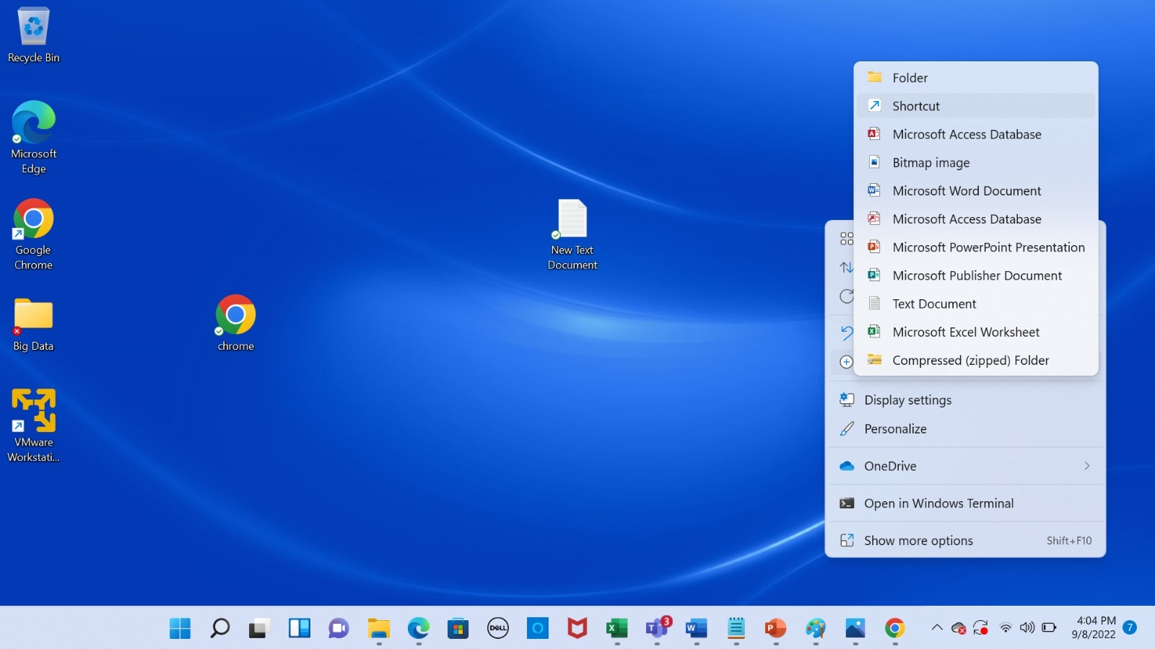

Add target as "[PATH_TO_CHROME]\chrome.exe" --disable-web-security --disable-gpu --user-data-dir=~/chromeTemp

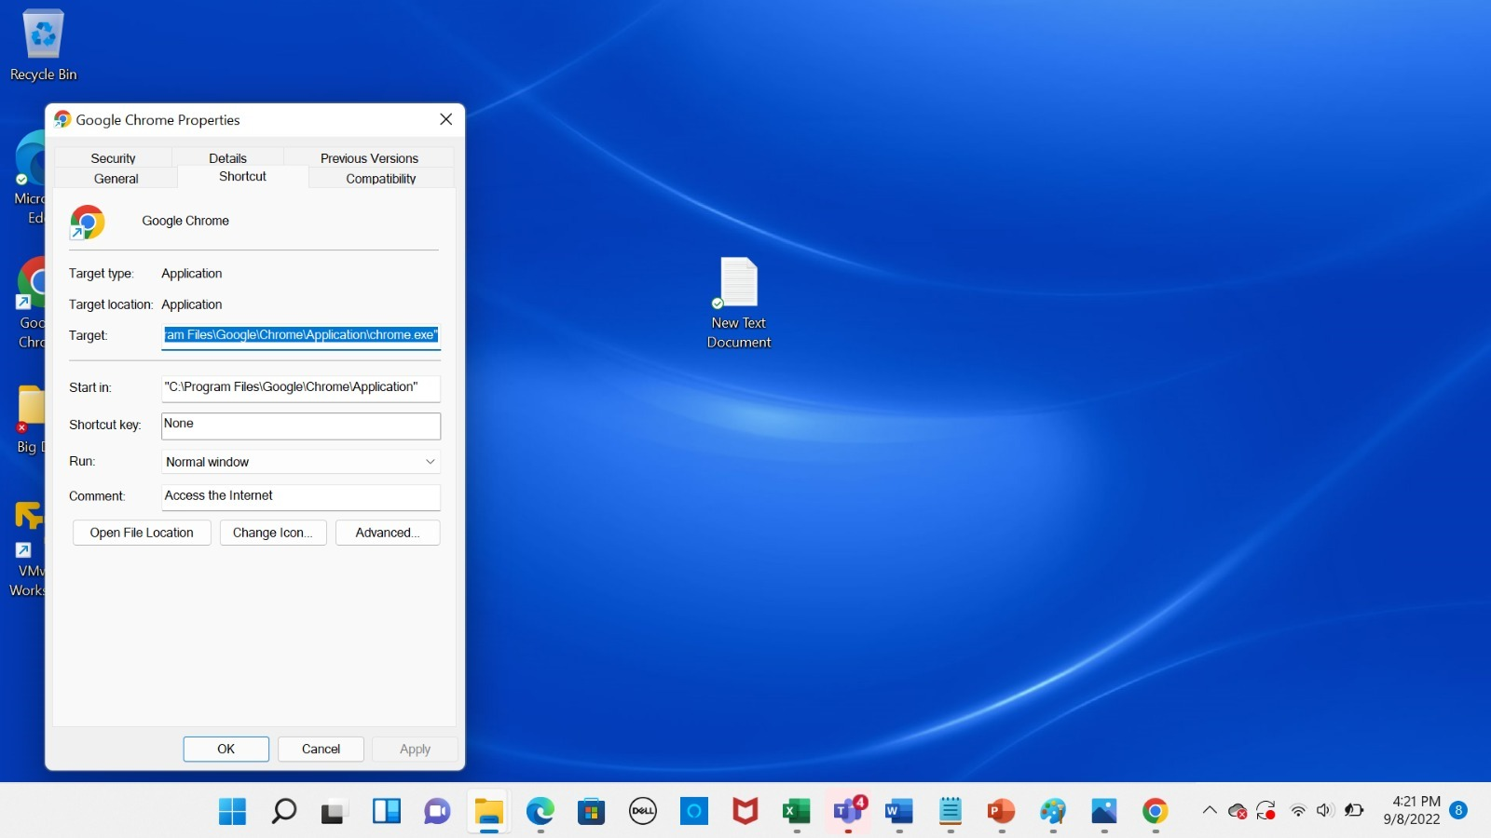

For [PATH_TO_CHROME]: copy and paste your path to chrome on your system for this part.



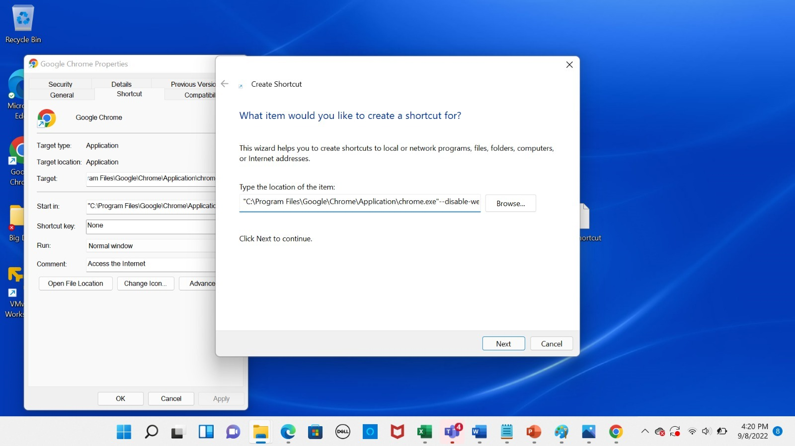

Click Next to continue

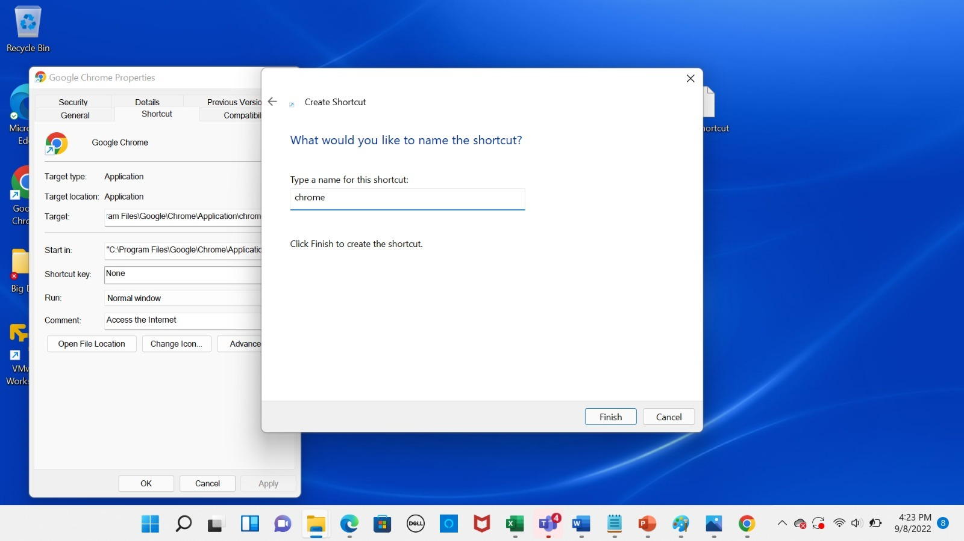

Under *Type a name for this shortcut* type Chrome, and click Finish.

Note: On windows 10 command will be: "C:\Program Files (x86)\Google\Chrome\Application\chrome.exe" --disable-web-security --disable-gpu --user-data-dir=~/chromeTemp

**For MacOS:**

Navigate to your applications folder. Open the appication called Terminal. Wait for the prompt to establish itself. Copy this command open -n -a /Applications/Google\ Chrome.app/Contents/MacOS/Google\ Chrome --args --user-data-dir="/tmp/chrome_dev_test" --disable-web-security and then paste it at the command prompt in Terminal. Press the enter key. Use this sequence any time you use the browser for this purpose.

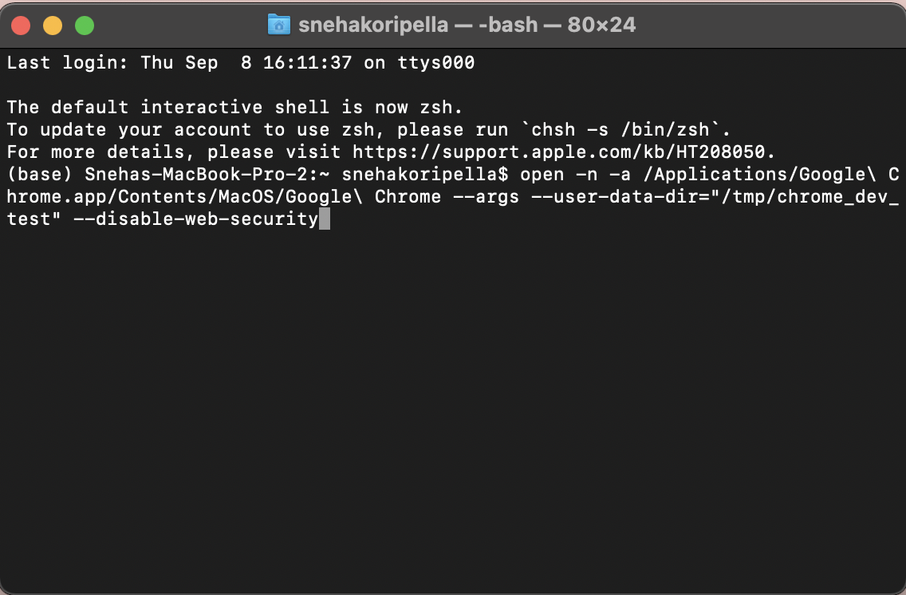

A new window for Google Chrome should pop up after this step

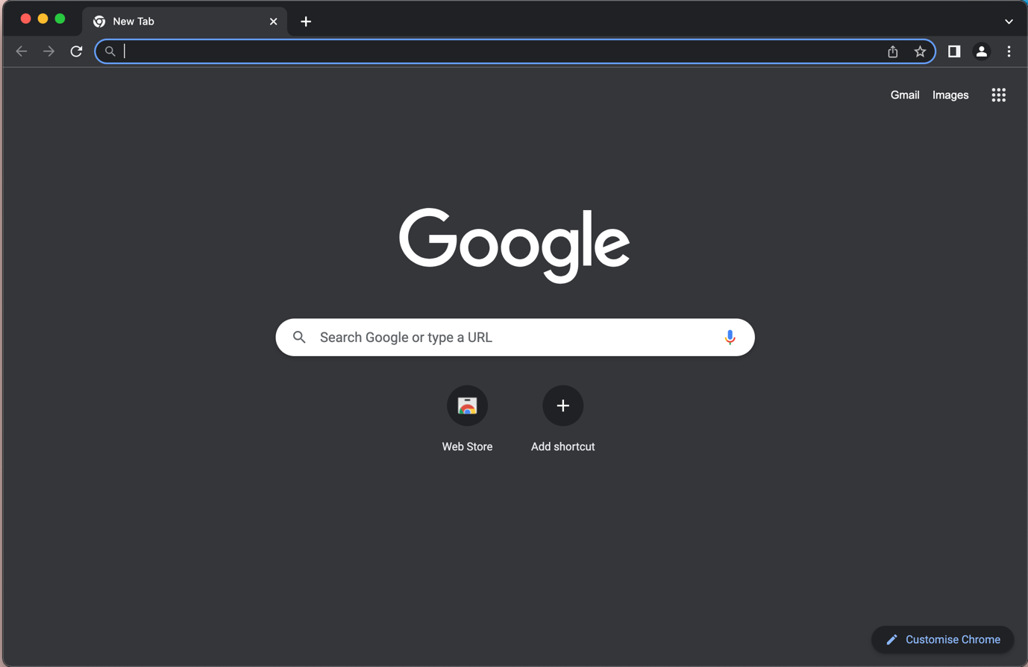

### Objective:

The objective of this exercise is to visualize university’s food data using D3

**Prerequisites:**

**Step 1: Installing Prerequisites**

1. Install Local server
   1. Install Wampserver for windows:

Prerequisites of installing “wampserver”:

Install Visual C++ 2012 Redistributable for windows users

<http://www.microsoft.com/en-us/download/details.aspx?id=30679>

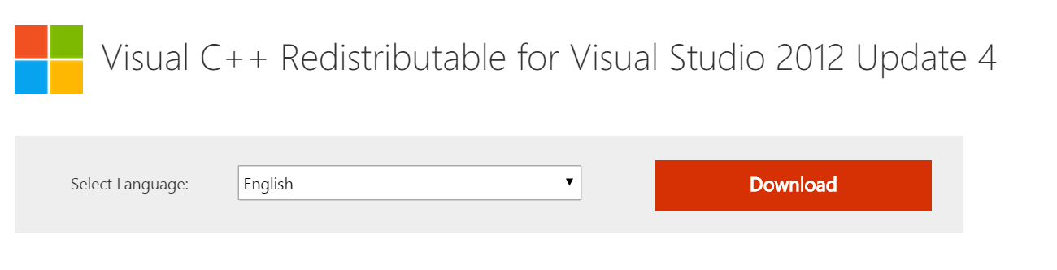

Once visual C++ 2013 redistributable is installed, install WampServer:

WampServer is a web development environment which allows you to create web applications. It installs local server environment on your windows system.

<http://www.wampserver.com/en/#download-wrapper>

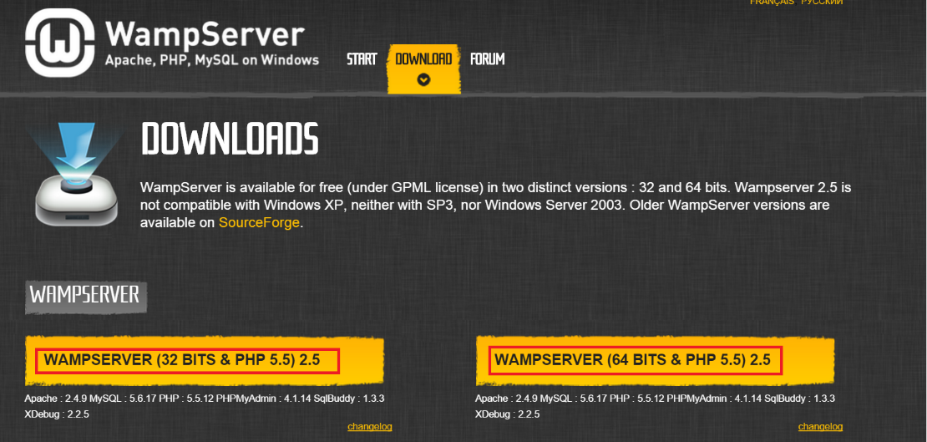

* 1. **Install MampServer for Mac**:

Installs local server environment on your Mac system.

<https://www.mamp.info/en/>

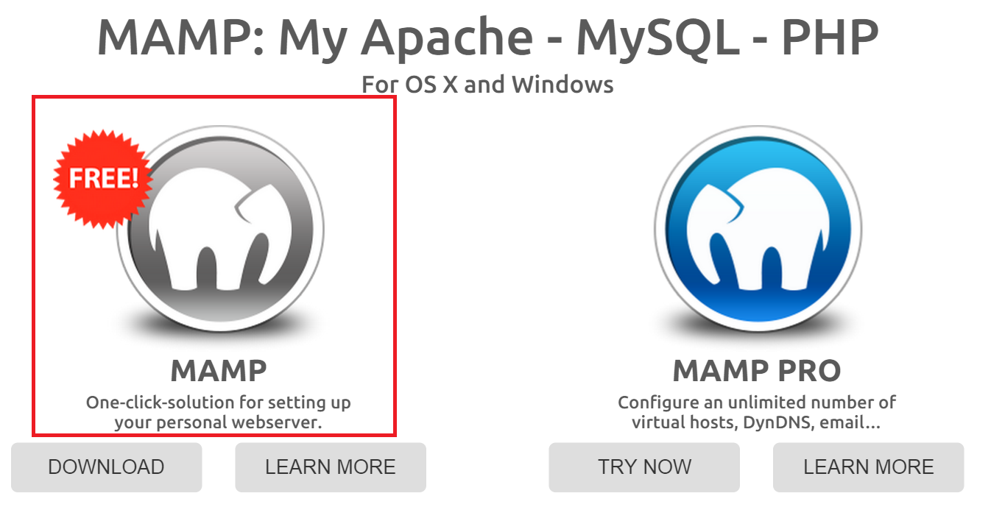

1. **Installing Sublime**

Install the latest version of Sublime using the following link:

<https://www.sublimetext.com/3>

**Step 2: Setting up Local Server**

Step 2.1: Setting up the WampServer for windows

After installing the WampServer. Search for the “Wamp” folder in your C:/ drive or the location where you had saved it. Double click on the “Wamp” folder, double click on the “www” folder. Within this folder we will be creating our eclipse workspace so that all the HTML documents that we create are already available in the server.

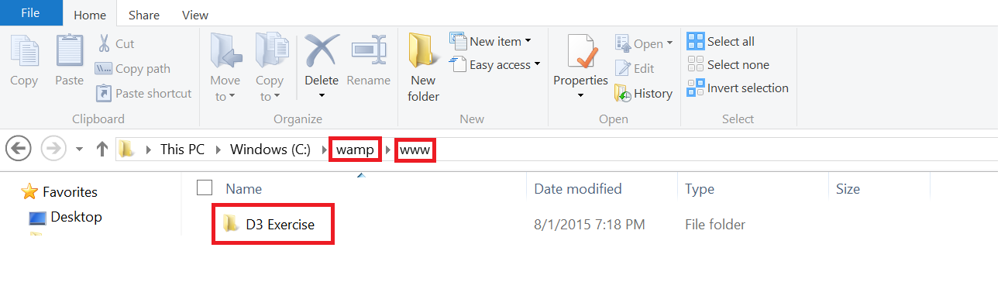

Open the wampserver. After opening the wampserver it will be visible in the desktop tray. At first you will notice that the wampserver icon will be in red which means that it is not active and at this stage if you open your webpages from the local server you will not be able to view them using the local server.

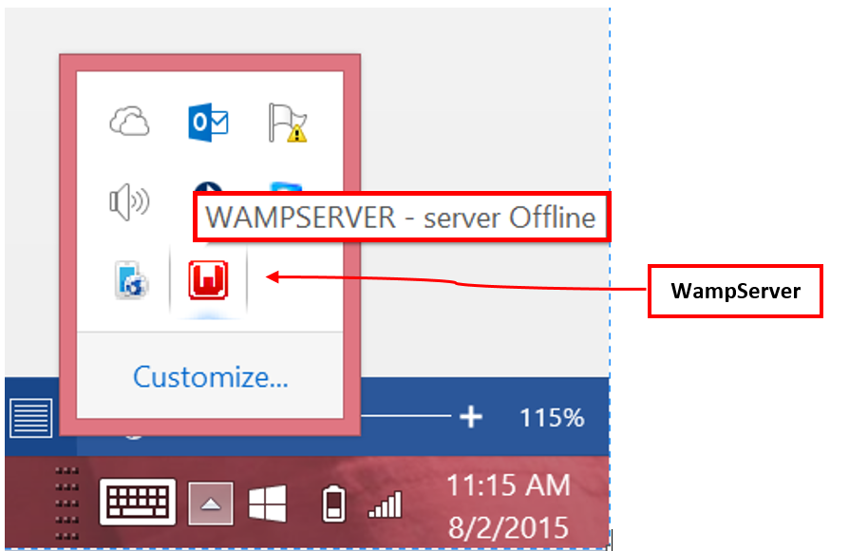

In order to display webpages using the local server we need to start the server. Click on the WampServer icon in the desktop tray and then click on “Start All Services”. This will make the WampServer icon to turn green which means now you can you’re your HTML documents and view them in the browser using our local host.

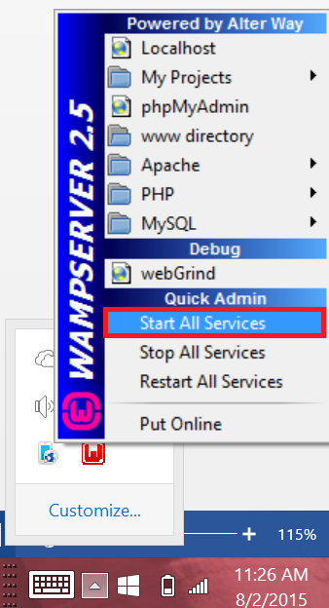

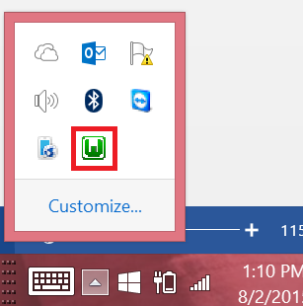

**Step 2.2: Setting up Mamp server for Mac**

After downloading the mamp server, install the mamp server by going to downloads folder and double click on the mamp file.

In the desktop create a new folder named “localhost”

After installing, go to the applications folder, double click on the mamp folder and then double click on mamp.app. A popup appears, click on Launch MAMP.

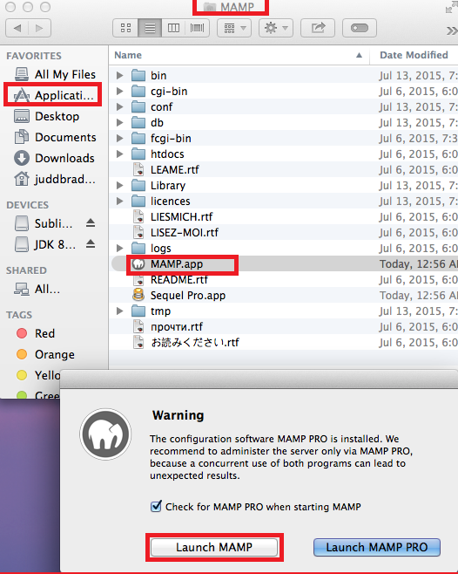

Another popup appears click on preferences,

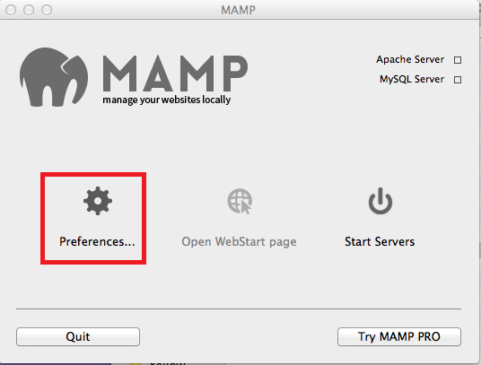

A new popup appears having 4 tabs. In the Start/ stop tab

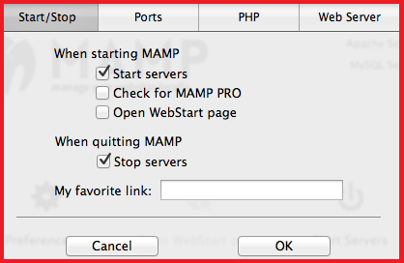

In the ports tab, click on the button highlighted below.

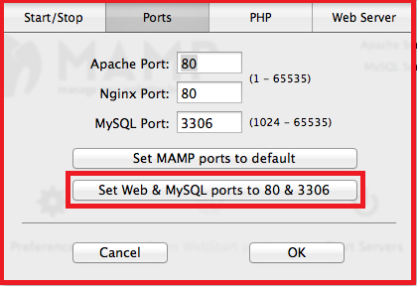

In the web server tab, select the folder icon highlighted below and then select the localhost folder created in the desktop.

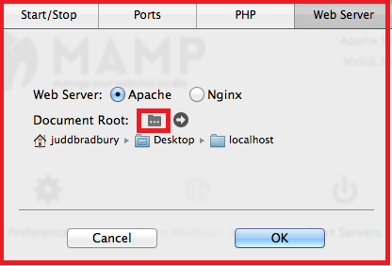

Once these settings are double click on the Mamp.app again under applications folder. In the popup, click on “Start Servers” in order to view your web pages in the local server.

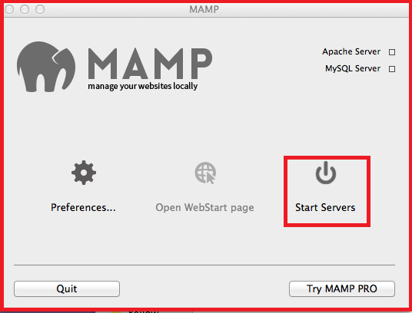

You can also stop the server by following the same steps.

**ALTERNATIVE:**

If you face CORS policy issues in Google Chrome, download the Chrome extension provided in the link below

<https://chrome.google.com/webstore/detail/web-server-for-chrome/ofhbbkphhbklhfoeikjpcbhemlocgigb?hl=en>

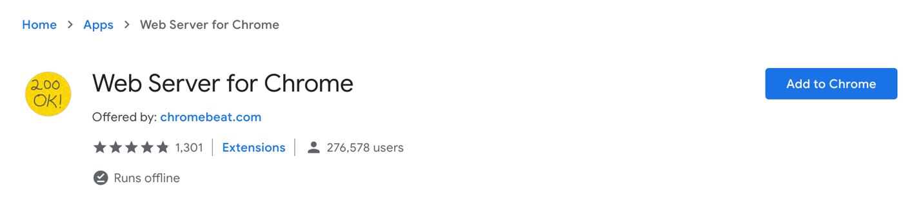

After you install it, launch the app. You will see this window:

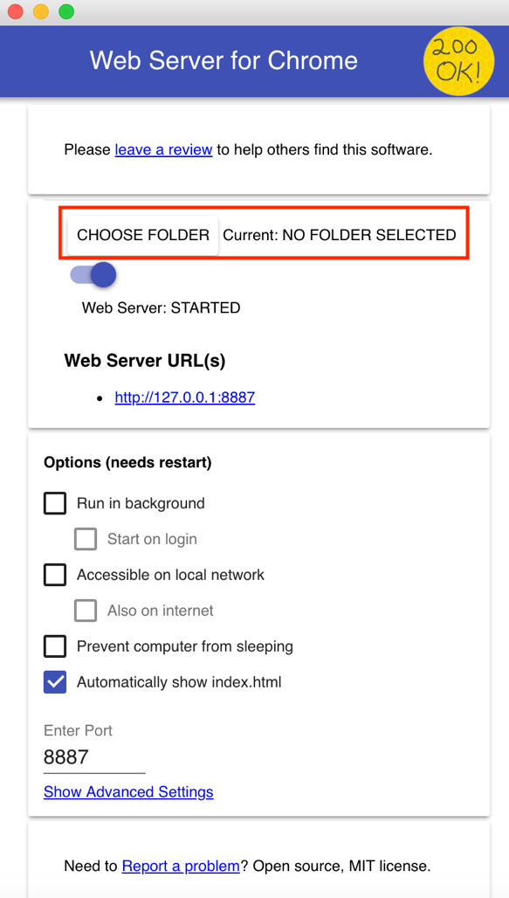

Go ahead and click on ‘Choose Folder’ and direct it to the directory where you have stored all your HTML/CSS/JS/CSV files. You can then click on the web server URL or go to <http://127.0.0.1:8887> to access your files locally.

**Step 3: Create a new folder and HTML file**

**Step 3.1: Setting the Sublime workspace**

Workspace is a place where we want all our files/documents that we create in eclipse to be placed. We will be setting the sublime workspace to “www” folder in WampServer or ‘localhost’ folder in mamp server as we want our html documents to be viewed on the local server. Open Sublime Text Editor and select the option as given in the screenshot:

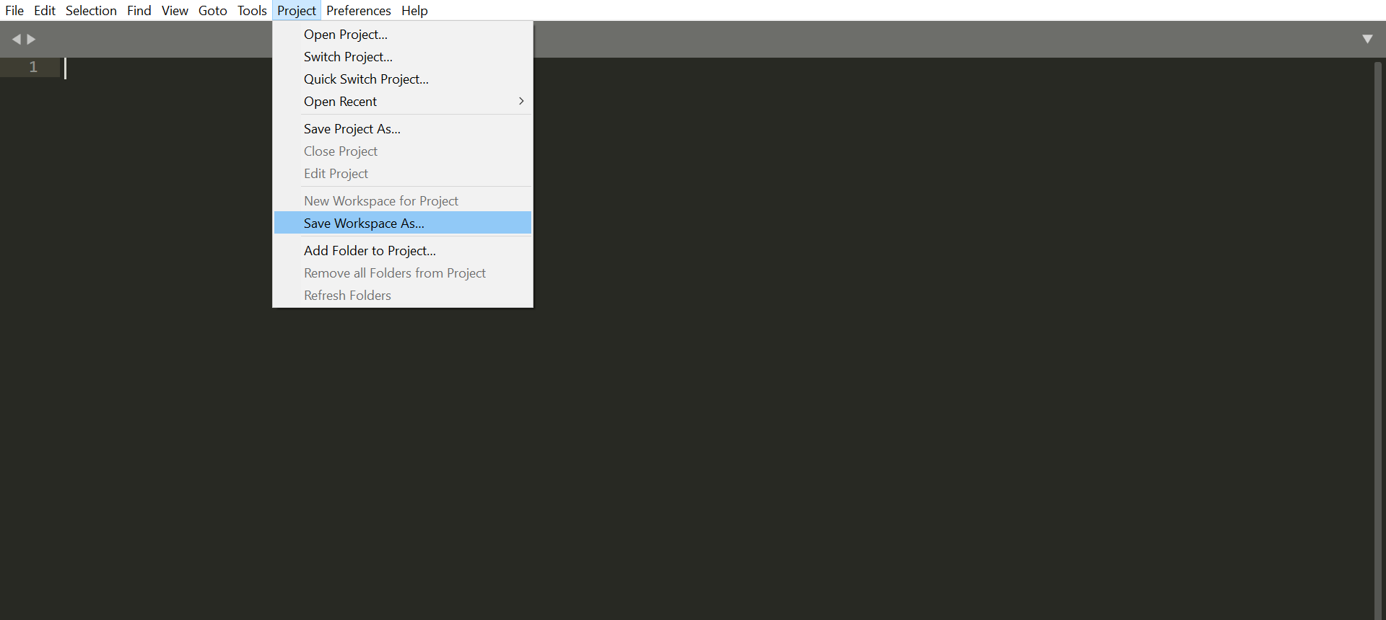

Windows Users: - Look for the wamp folder and expand it and select www folder (for windows), name it as “D3_Exercise” and then click ok.

Mac Users: - localhost folder under desktop folder in Mamp server (for mac users), name it as “D3_Exercise” and then click ok.

Now your workspace is set so whatever you create in Sublime would be saved under the www folder under wamp folder (in windows) and under localhost folder in desktop (in Mac).

**Step 3.2: Create a new folder under your project in Sublime**

Follow the below menu path to create a new folder.

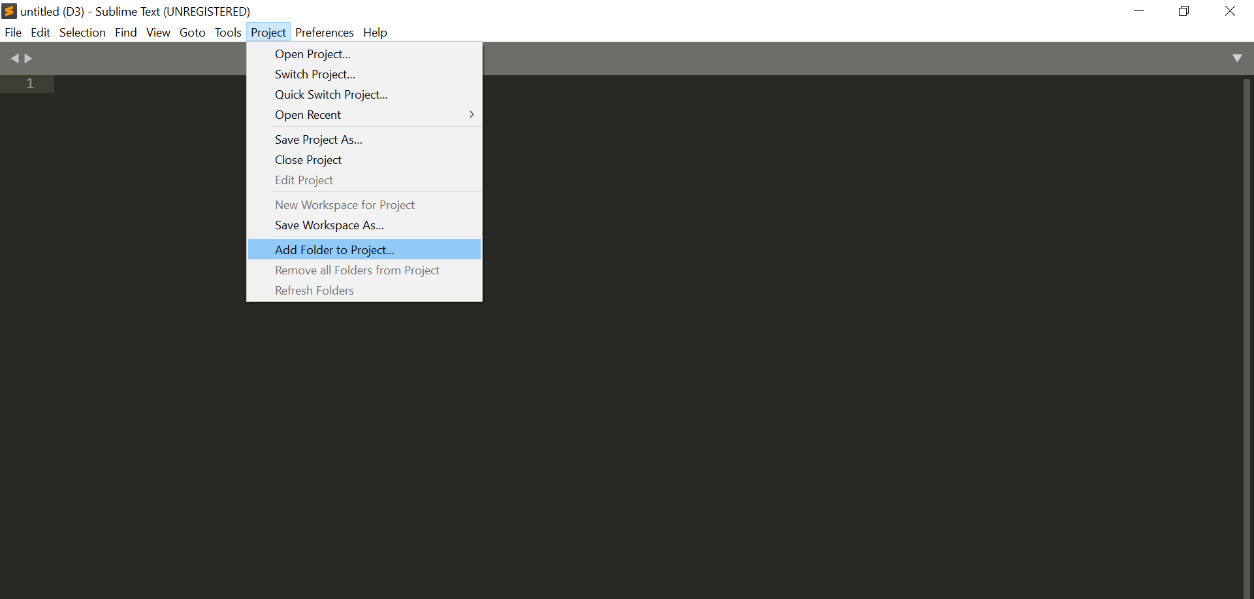

Once you select “Add Folder to Project”, choose the “www” folder under wamp64 folder in your system.

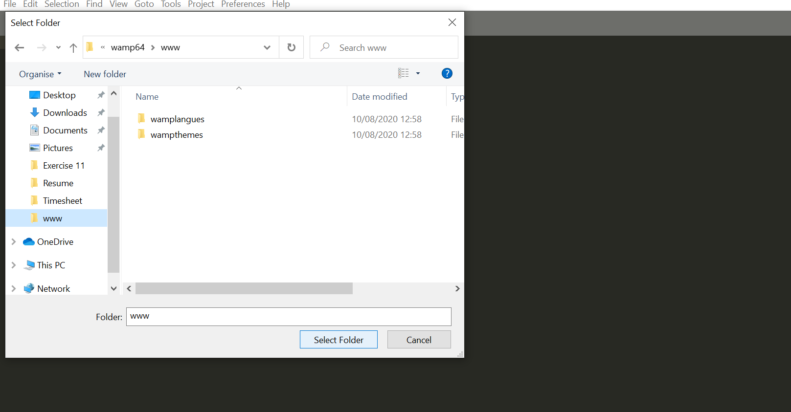

Now, right click on the “www” folder and choose new folder. Name the folder as “D3_ExerciseSublime” as given in the screenshot:

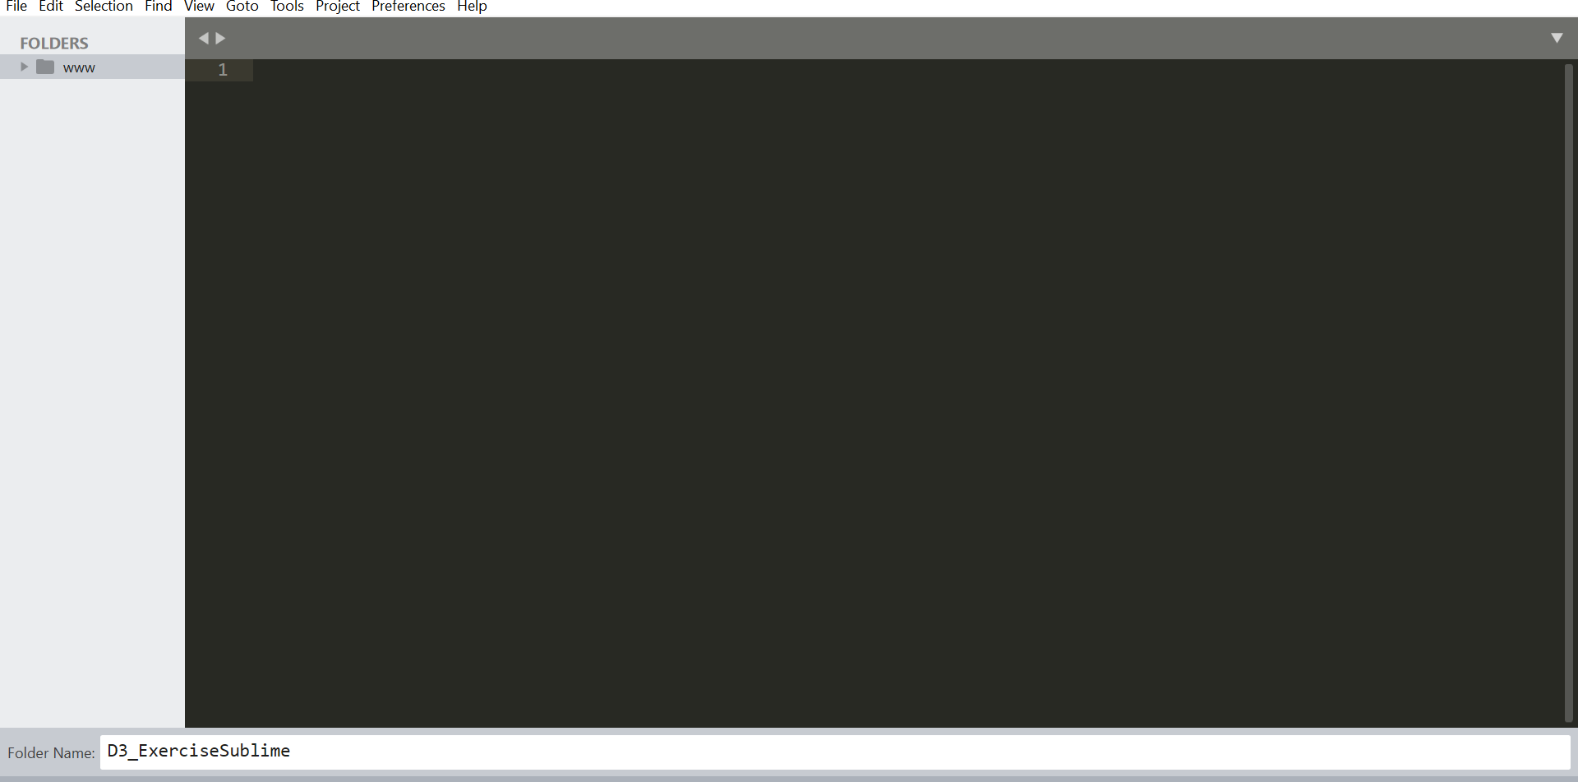

Step 3.3: Create a new file inside the folder in Sublime

Now we will create a file inside the folder in order to keep all the HTML documents organized in one place.

Right click on the folder name, select New File.

**Step 4: Download dataset from ELearning**

* Download the ‘University_Food_Data.CSV’ file from eLearning and save it in above created folder. To access D3_ExerciseSublime folder go to your ‘wamp’ folder-> www->D3_ExerciseSublime



* Get top three selling menu items for each store
  + Open downloaded csv file
  + Create a new csv file
  + Copy column header from downloaded csv to newly created csv
  + In downloaded csv sort data by Gross_sales (largest to smallest) and Store_Name (A to Z)
  + There are 9 different stores in dataset, apply filter on Store_Name and for each store get top 3 items by gross sales and copy it into newly created csv file. For example in filter value of Store_Name select ‘Coffee Corner’ and get top 3 items by gross sales and copy it into new csv
  + After completing above step for all 9 stores, you will have 28 records in new csv, 1 header record and 27 other records, save newly created csv file as food_court filtered data.csv

**Step 5: Create HTML file**

HTML stands for Hyper Text Markup Language. It makes use of tags to create web pages. It is used to structure the web pages.

Every HTML code, is divided into a header section and a body section which are represented by header start and end tags (<head> </head>) and body start and end tags (<body> </body>). Between these start and end tags we place the contents of the web page.

Write the following HTML code in the newly created file

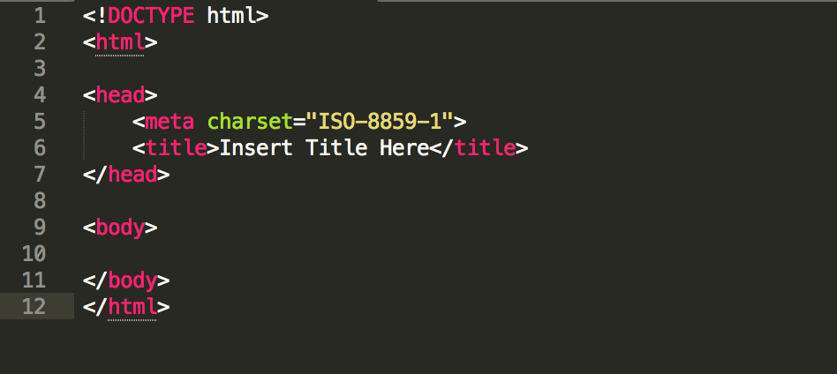

Load D3 library and create CSS style for page’s background color and svg’s background color:

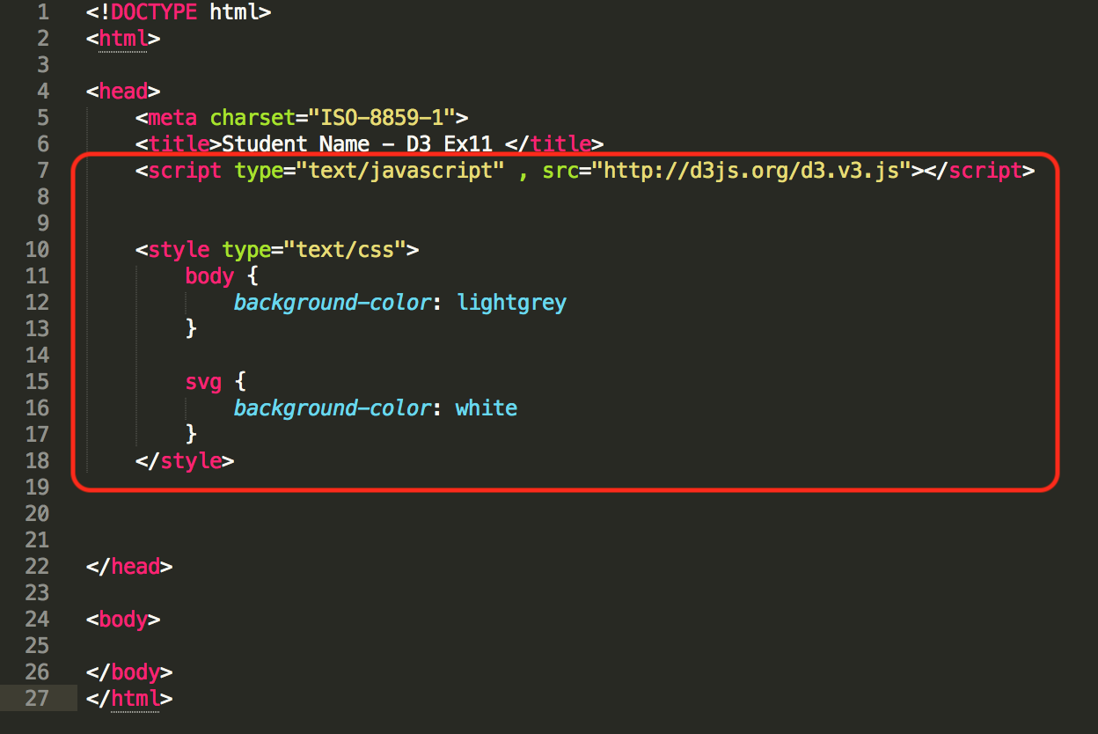

One you have completed writing the above html code then save the file as “StudentName_D3”(HTML_document- in the screenshot) and choose the file type as .html as given below:

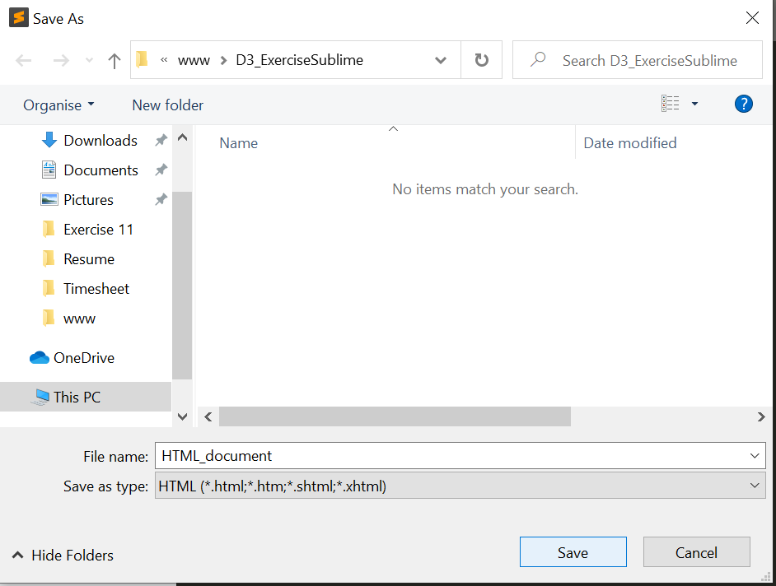

**Code Explanation:**

* + - Adding title using title tag
    - Loading D3 library usinglink ‘http://d3js.org/d3.v3.js’so that D3 functions can be used in this HTML page
    - Using style tag setting css style for body background and svg background color

Step 6: Display the HTML document on browser

* In order to display the webpage on the local server. Open any browser and type
* “localhost/ D3_ExerciseSublime/” and then press enter.
* Click on the folder you created in Step 3.

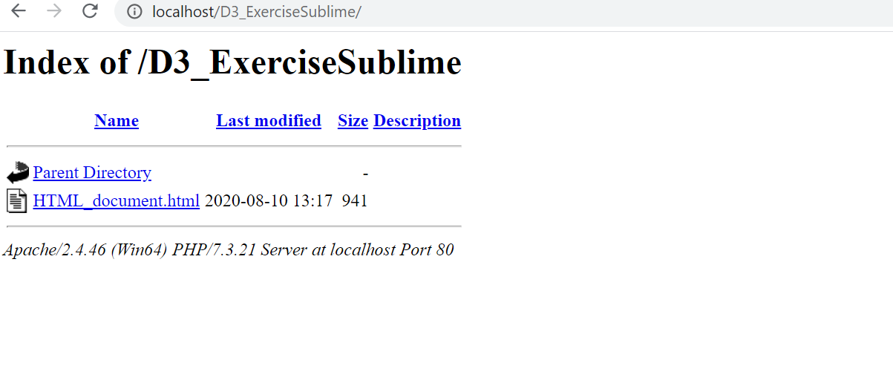

* All the HTML documents you created will be visible here. Click on the HTML_Document.html(in your case- StudentName_D3) to view your web page.
* Note: In case you are unable to view the contents in the web page then refer to Web server for chrome to check for errors.

### Question:

### Open your HTML page in WEB browser and take a screen shot of your page showing page Title (your name) and page background

Answer

----------------------------------------------------------------------------------------------------

**Step 7: Create a division and SVG image**

* Add a center aligned division and SVG image in your HTML page

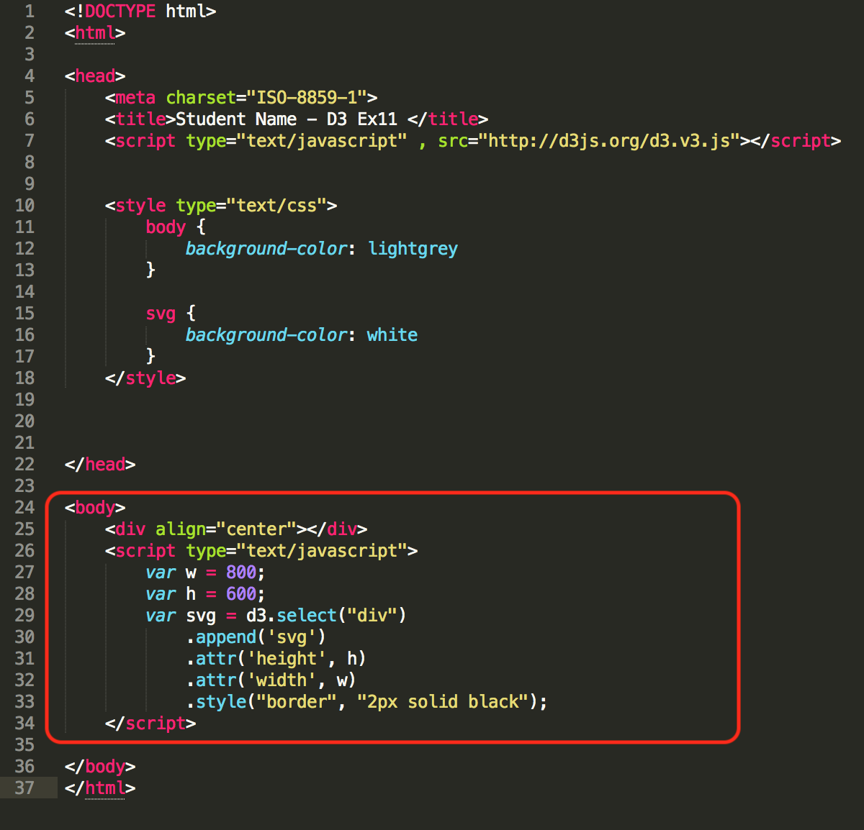

Code Explanation:

* + Create a svg frame and assign it to the variable svg.
  + Use the function d3.select to find the div tags present in the body. There is only one div tag present in the body.
  + Append the svg frame in the div tag and set the attribute such as height and width of the svg frame as mentioned in the variable "v" and "h".

**Question:**

1. **Provide the screenshot of your html page displaying your name in the browser tab:**

Answer

----------------------------------------------------------------------------------------------------

Step 8: Fetch dataset using D3:

* Make sure you have created new csv file as per instructions given in step 2 and stored it in ‘D3_ExerciseSublime’ folder created in step 1
* Get csv data into your HTML page using D3function and write data in browser’s console

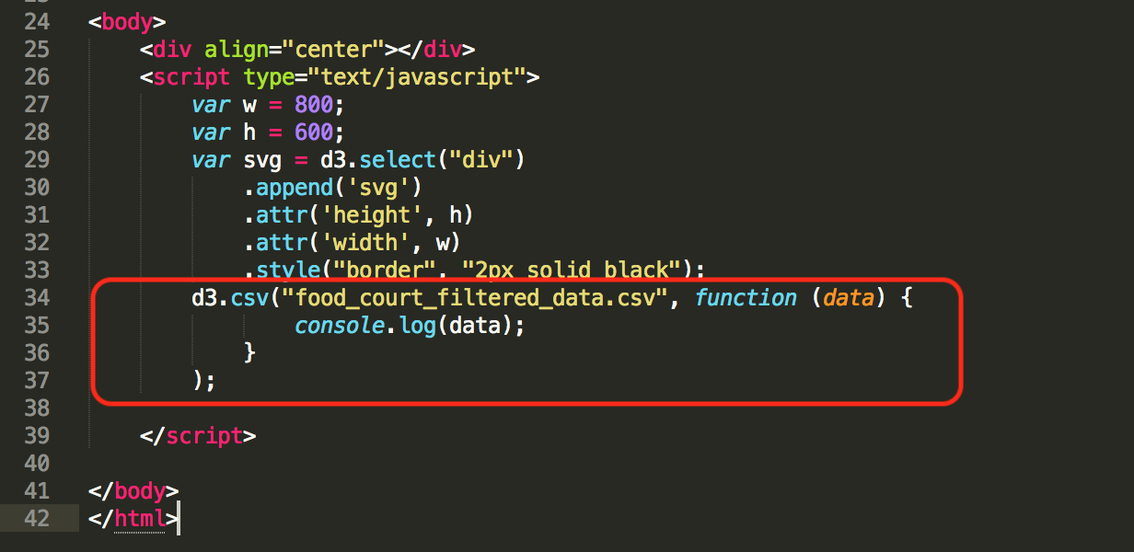

**Code Explanation**:

* + d3.csv function will pull the data and from the file that will be passed as an input parameter. In this case, the file is "food_court filtered data.csv".
  + This data will be passed as an input variable for a function.
  + The value that will be returned will be displayed in the console using console.log function.
* Check in browser console if data is pulled from csv

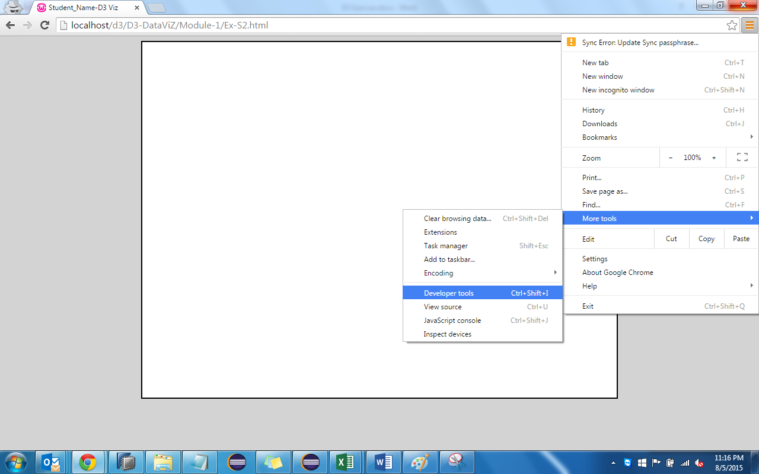

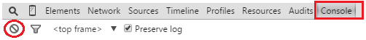

**Question:**

1. **Place the screen shot of your console showing data (objects)**

**Tip: Clear console using button marked with red circle and refresh the page**

Answer

----------------------------------------------------------------------------------------------------

Step 9: Create bar graph visualizing Gross Sales of various food items

* Before creating bar graph we will sort the data, write below piece of code to sort the data

Note: We have removed console log (data), it was just for testing purpose

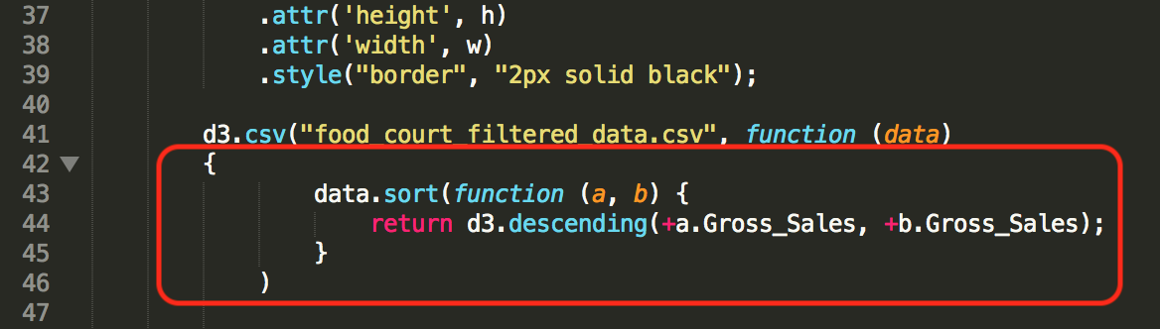

Note: Labels are case sensitive. If csv labels is named as Gross_Sales, your

code should address label as Gross_Sales and not Gross_sales

Code Explanation:

* + Once the data is pulled into the variable data, it can be sorted using the function sort which can be called using the variable "data" that contains the dataset.
  + The function d3.descending will sort the data in descending order and will return the data.
* To create bar chart we need to first create rectangles (rectangles = bar of bar chart) corresponding to records in our dataset and then we will set property of each bar

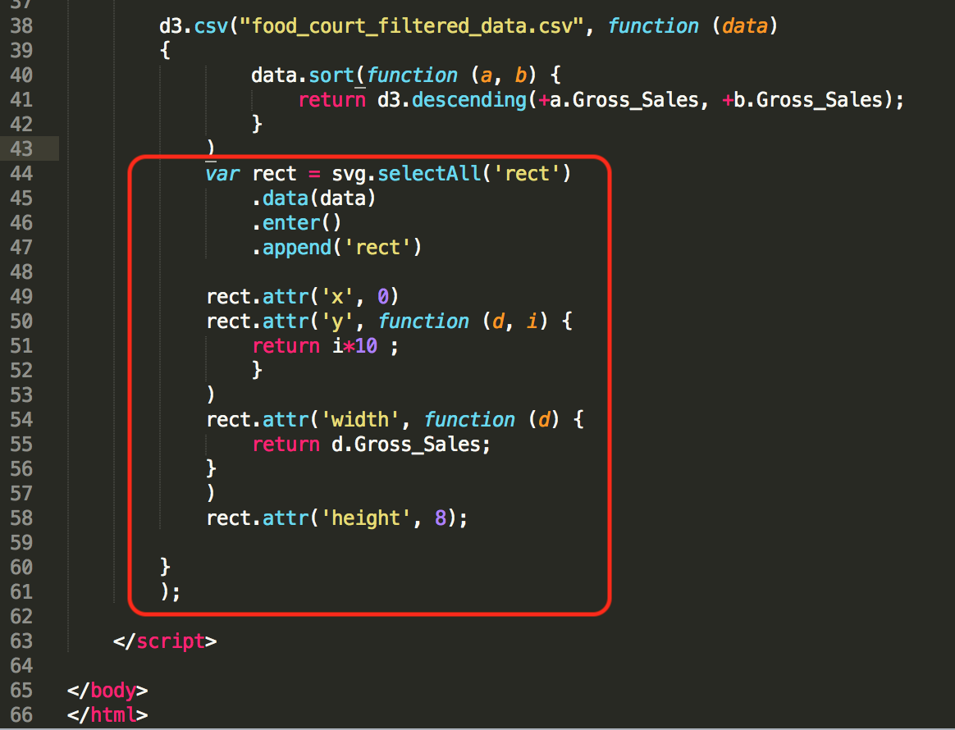

**Code Explanation**:

* + In order to create rectangles using a consistent height and width, rect.attr can be used to set the x and y coordinates of the rectangle.
  + The rectangle will have the same x coordinate and height for each rectangle will also remain same.
  + The only difference would be the y coordinate for the rectangle, ‘i’ is the index of each record and we are multiplying i by 10 so that each record or bar should have distinct starting location
* Refresh your webpage, it should look something like this:

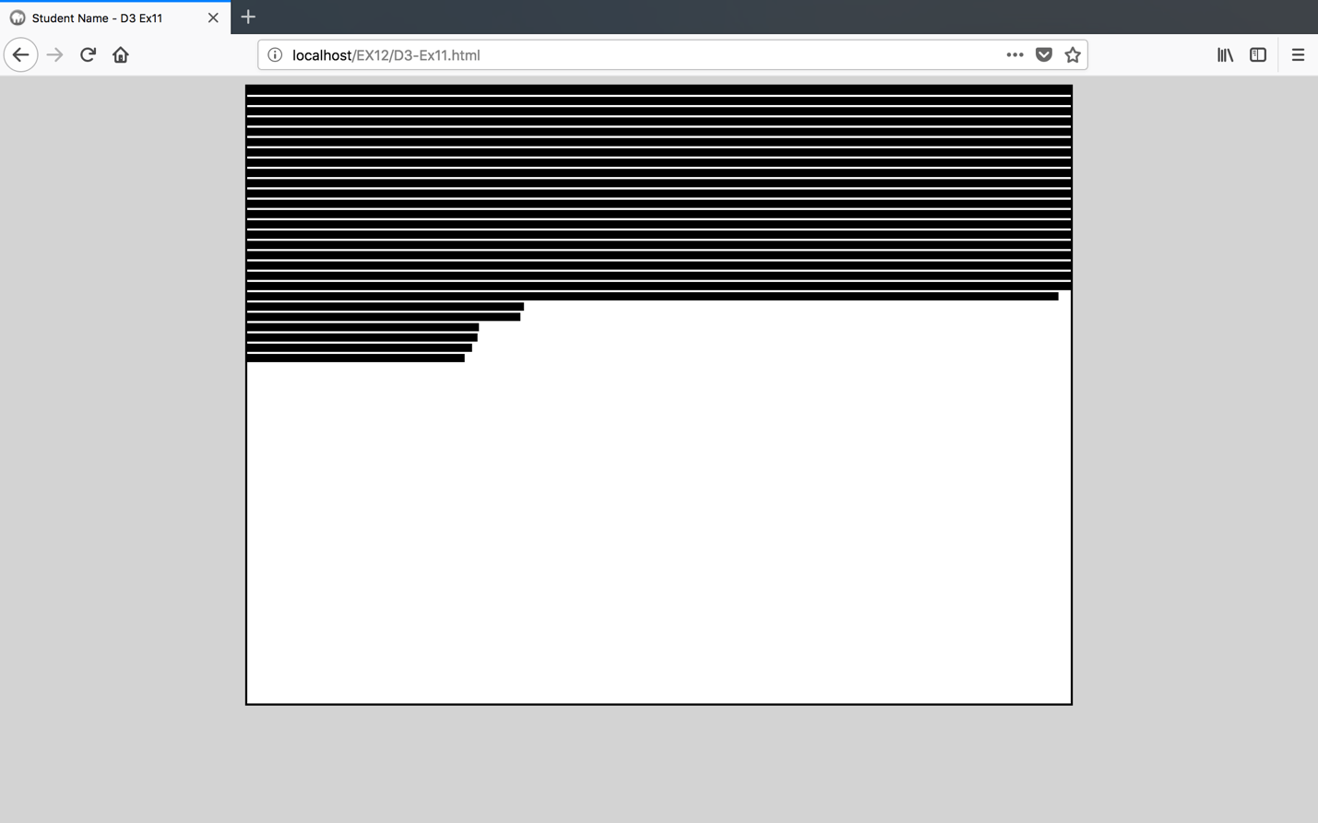

**Question**:

1. **Refresh your web page and paste a screenshot**

Answer

----------------------------------------------------------------------------------------------------

Step 10: Scale the graph

* Horizontal Scaling
  + As of now the bar graph that we have created is not scaled, so first we will scale the width of the graph, make following changes in the code:
  + Create a new variable widthScale and set the range 0 to width of svg

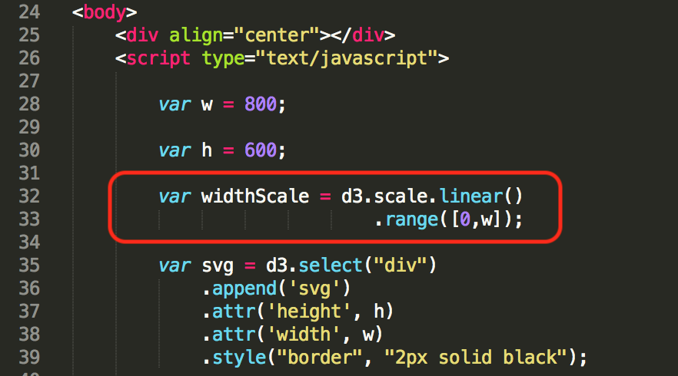

Code Explanation:

* + WidthScale for the rectangle will help in creating the rectangles based on different size dynamically. The function d3.scale.linear.domain and d3.scale.linear.range will map the values of the input variables to the output variables
  + Eg. if d3.scale.linear.domain contains value between 0 -200 and range contains value 0-500 then the input value of 100 will be mapped to an output value of 250.
  + Add below piece of code to set the domain of the scale

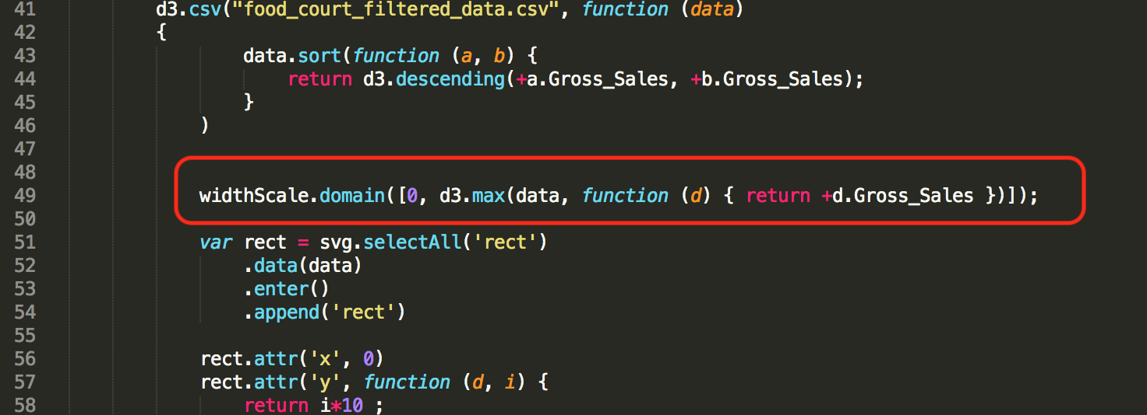

Code Explanation:

* + The above code adds the domain value for the widthScale that was defined in the previous step.
  + Replace the code written inside width attribute of the rectangle with below piece of code

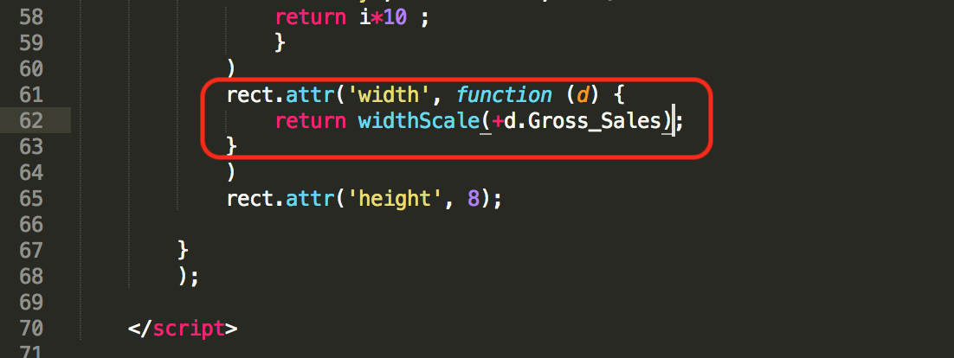

Code Explanation:

* + As mentioned in the above steps the values of widthScale for domain and range will map the input to the output values.
  + Thus, when Gross sales will be passed as a value to the function widthScale, the values will be mapped to their equivalent output value similar to the e.g. mentioned in the previous step.
* Refresh your webpage, it should look something like this:

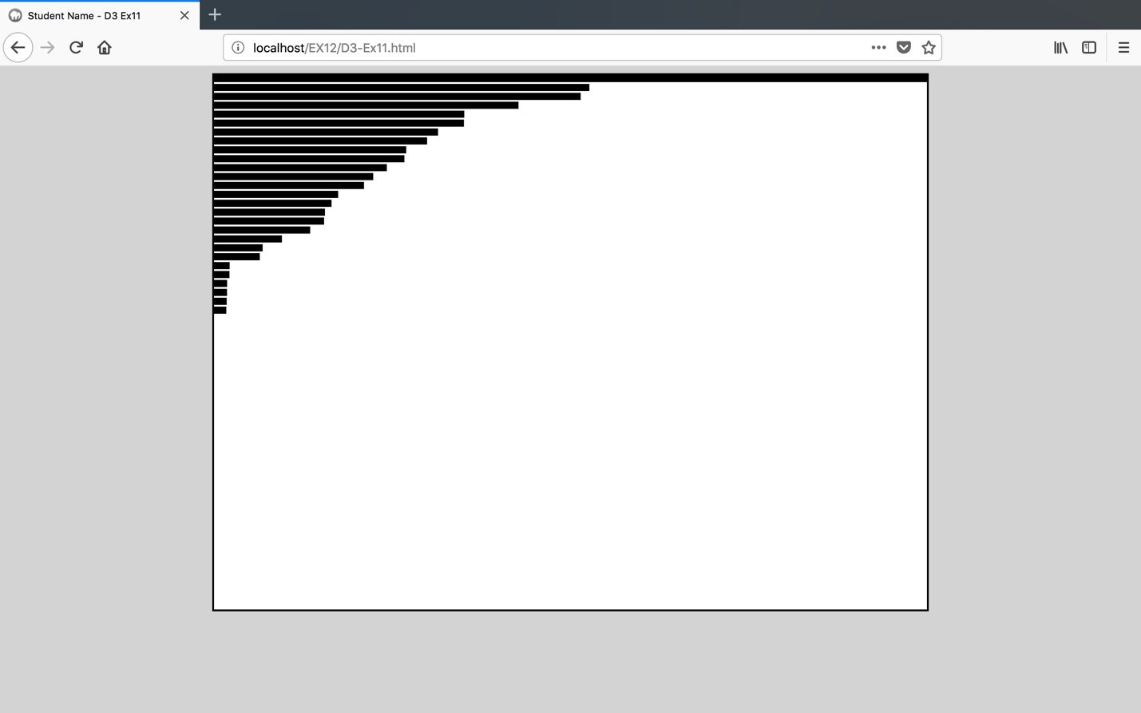

**Question:**

1. **Provide the screenshot of your html page displaying your name in the browser tab:**

Answer

----------------------------------------------------------------------------------------------------

* Height Scaling
  + Make following changes in the code to scale height of the graph:
  + Create a new variable heightScale and set the range 0 to height of the svg

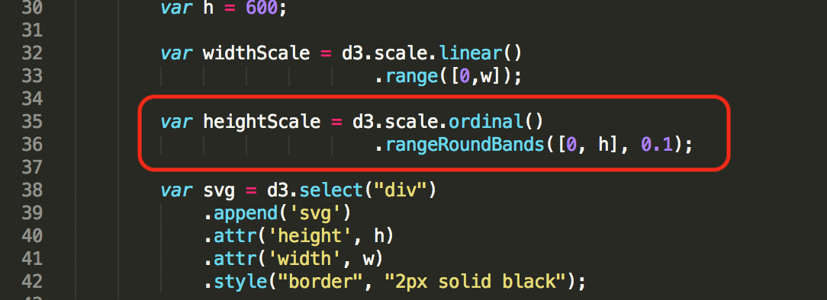

Code Explanation:

* + The widthScale will map the numerical input values to their numerical output values.
  + The ordinal scale will map the categorical input values to their categorical output values
  + Add below piece of code to set the domain of the scale

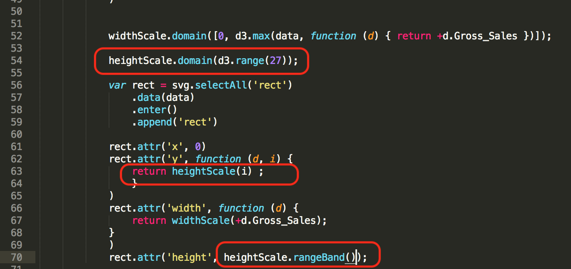

Code Explanation:

* + heightScale.domain function will set the input range for the heightScale variable.
  + In this case, the values is set to 27 so the input range would be from 0-26.
  + Replace the code written inside Y attribute and height attribute of the rectangle with below piece of code

**Question:**

1. **Provide the screenshot of your html page displaying your name in the browser tab:**

Answer

---------------------------------------------------------------------------------------------------

Step 11: Add padding (margin) to the graph

Before adding axis to the graph we need to create some padding i.e. we need to make some space to the right, left, bottom and top of the graph

Make following changes in the code to add padding:

Create new variable padding:

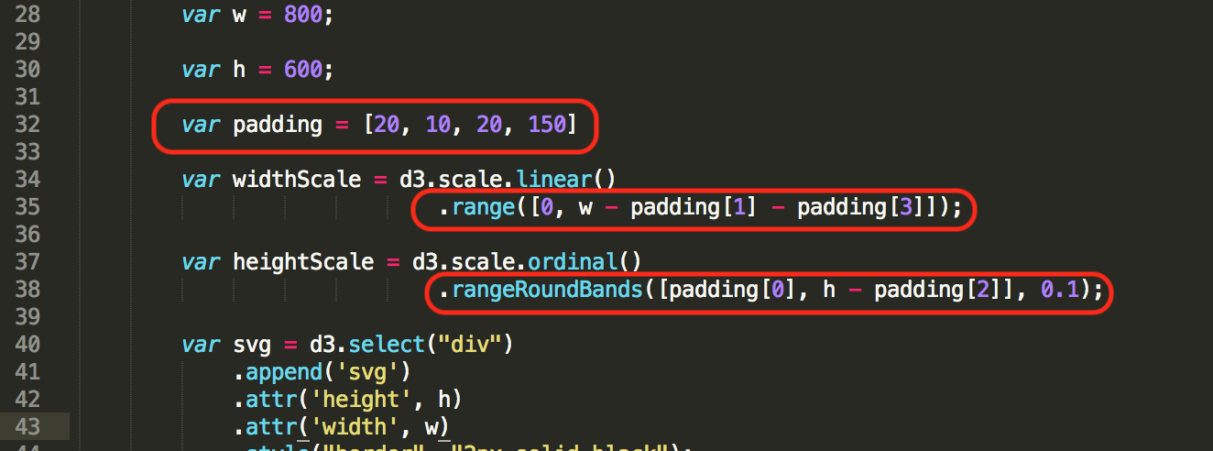

Code Explanation:

* Padding variable consists of an array whose values can be used to append space around the svg frame. The order of the alignment is mentioned in the comments.

To reduce width and height of the graph or in other words to add padding to the right and bottom of the graph make following changes in the width and height variables:

Without refreshing current tab open your webpage in a new tab/window and compare the graph with previous tab, your graph should look like this:

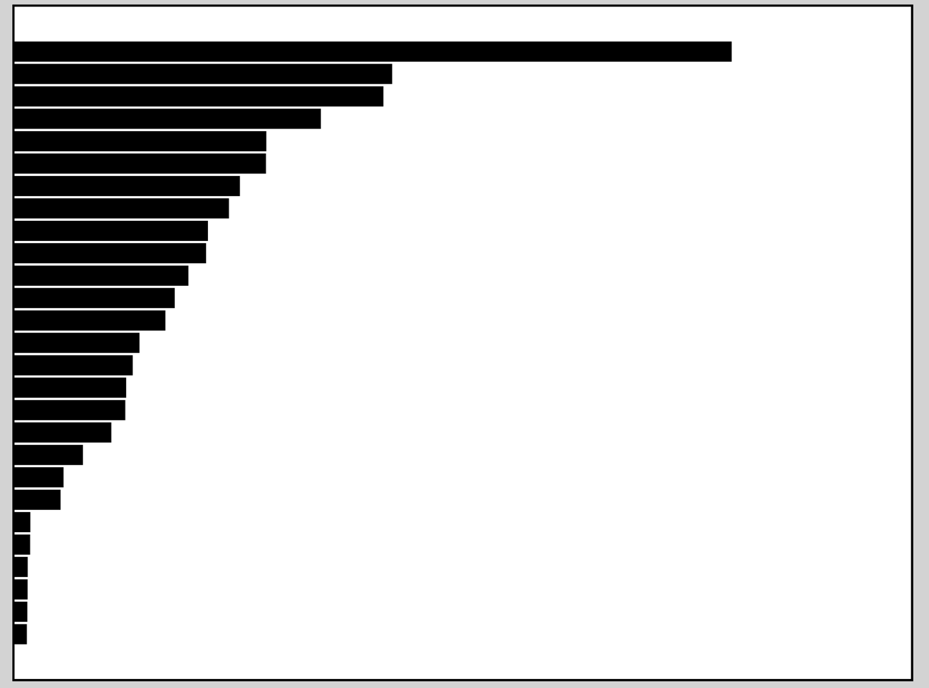

To add padding to the left of the graph, make following code changes in X attribute of rectangle:

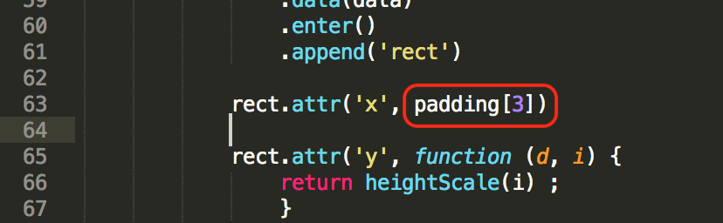

Code Explanation:

* + The x coordinate for the rectangle will be set using the variable padding[3].This will set the x coordinates to the value mentioned in padding[3].

**Question:**

1. **Provide the screenshot of your html page displaying your name in the browser tab:**

Answer

---------------------------------------------------------------------------------------------------

Step 12: Add x-axis and y-axis

First we will add x-axis to our graph, make following changes in the code to add x-axis:

To give style to our axis add following css style code

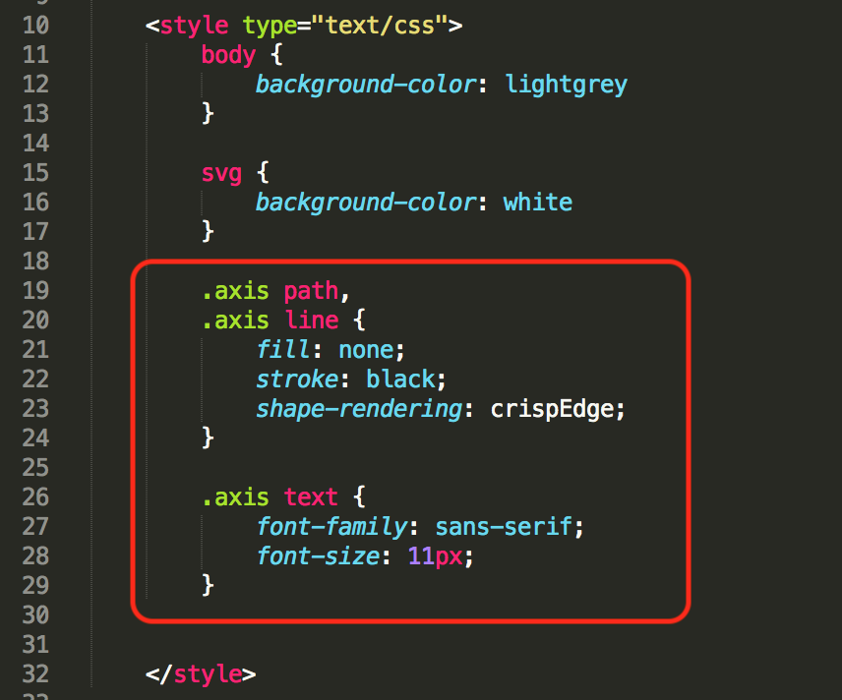

Code Explanation:

* + Formatting for the axis in the svg can be done using .axis path and .axis line.
  + .axis text will set the font size and family of the text for the axis in the svg frame.

Create a new xAxis variable

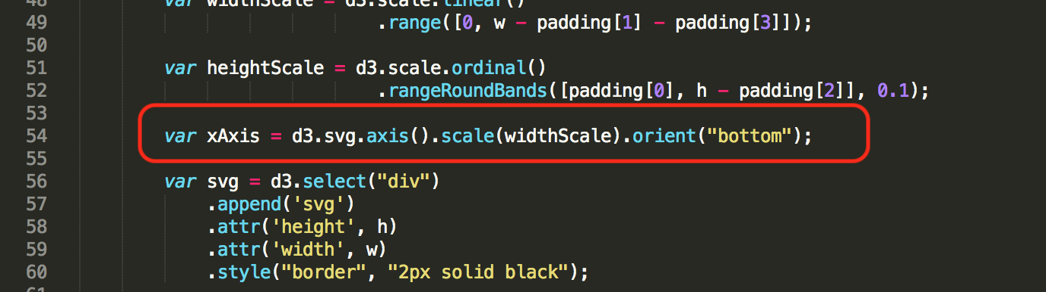

Code Explanation:

* + Orient function will place the text of the x axis at the bottom of the x axis.

Add a group element in svg image to display x-axis

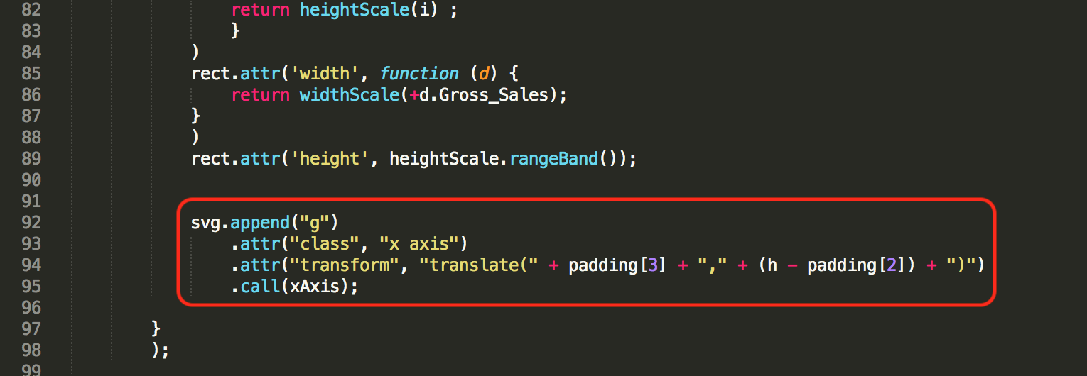

* Refresh your webpage, it should look something like this:

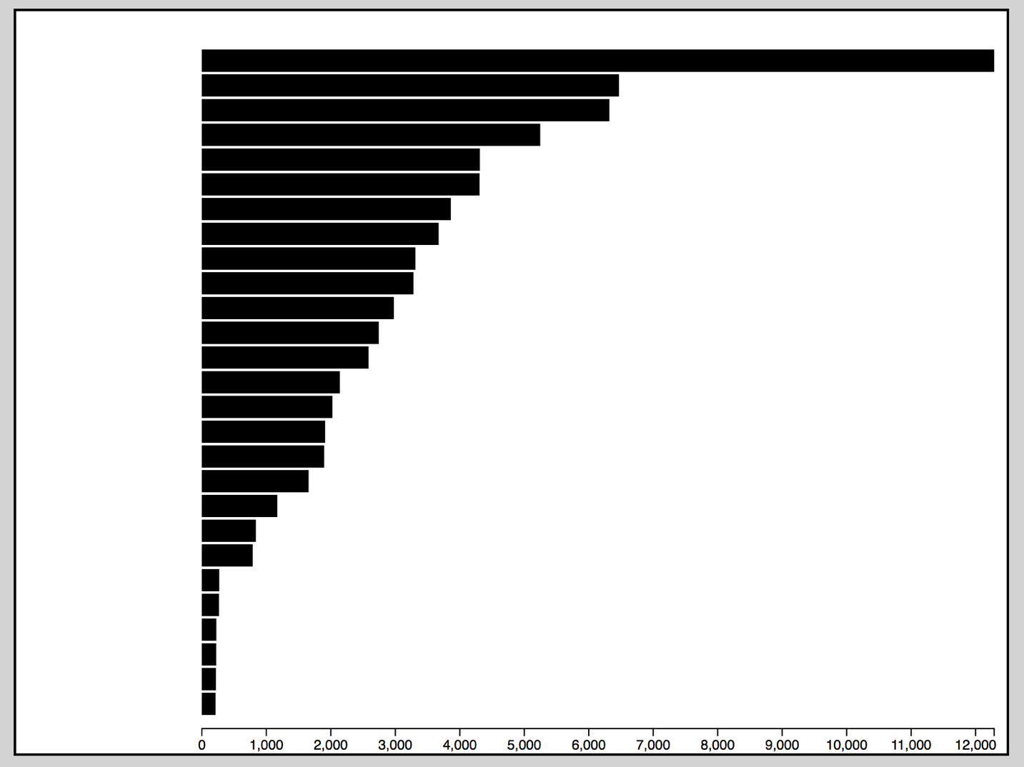

* Now we will add y-axis to our graph, make following changes in the code to add y-axis:
* Create a new yAxis variable

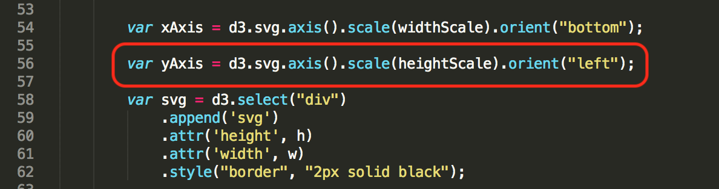

Code Explanation:

* + Similar to the vertical y axis the text values will be to the left of the axis using the orient function

Add a group element in svg image to display y-axis

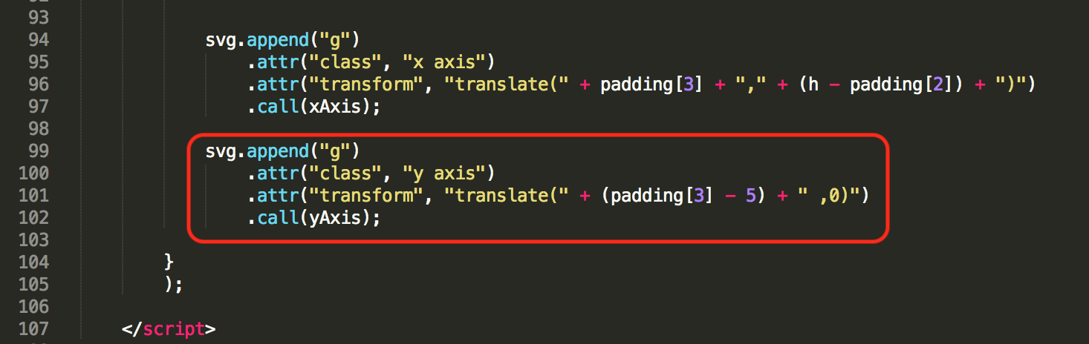

* Make following changes in the code to label y-axis

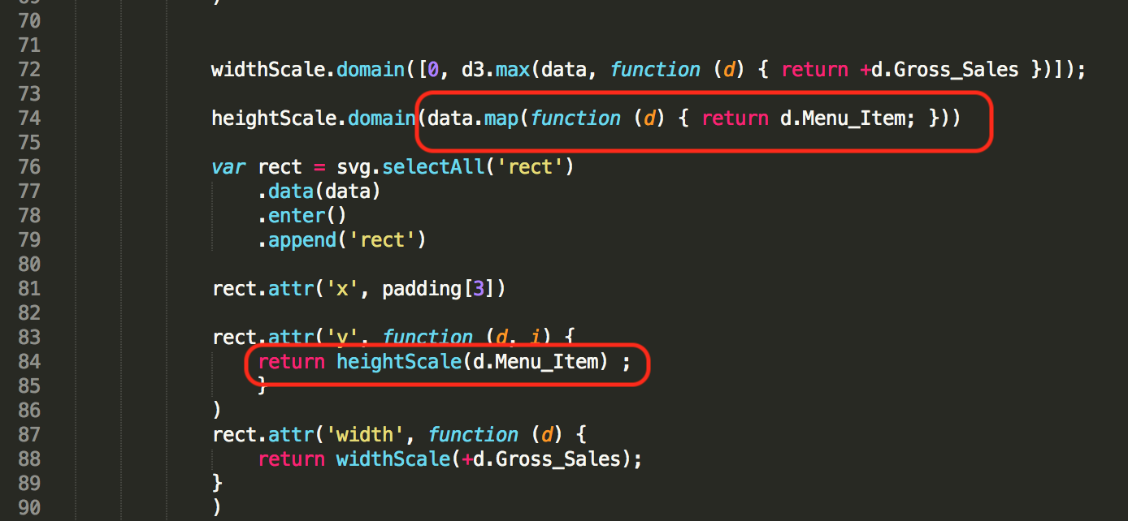

Code Explanation:

* + The value for the y axis from the previous steps contain range from 0-26. This range value has to be replaced with a meaningful categorical value.
  + For the food court dataset the value will be replaced with the menu items.

**Question:**

1. **Provide the screenshot of your html page displaying your name in the browser tab:**

Answer

----------------------------------------------------------------------------------------------------------------

Step 13: Color code Store Names

* There are nine different store names in our dataset and now we will color code them
* Add a new color variable containing range of 9 different colors, one for each store

Code snippet

var color = d3.scale.ordinal().range(["#98abc5", "#8a89a6", "#7b6888", "#6b486b", "#a05d56", "#d0743c", "#ff8c00","#C9FF00","#FFDA00"]);

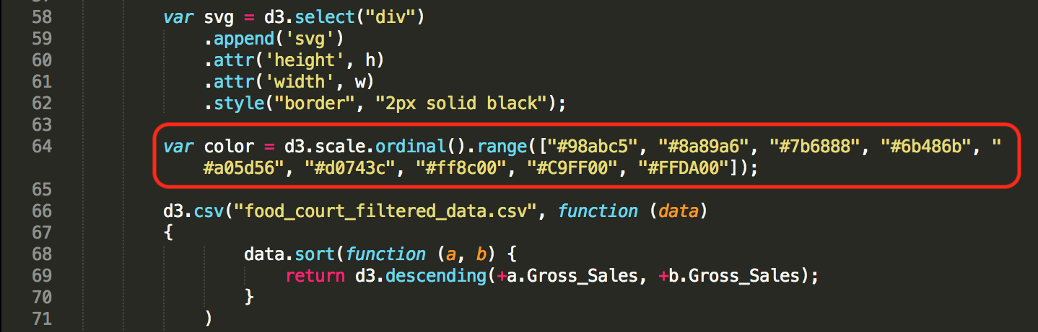

Code Explanation:

* + Create an ordinal scale variable color and set the range for the categorical variables with the color code that is to be assigned to distinguish the clusters.
* To map each color with store name add below piece of code:

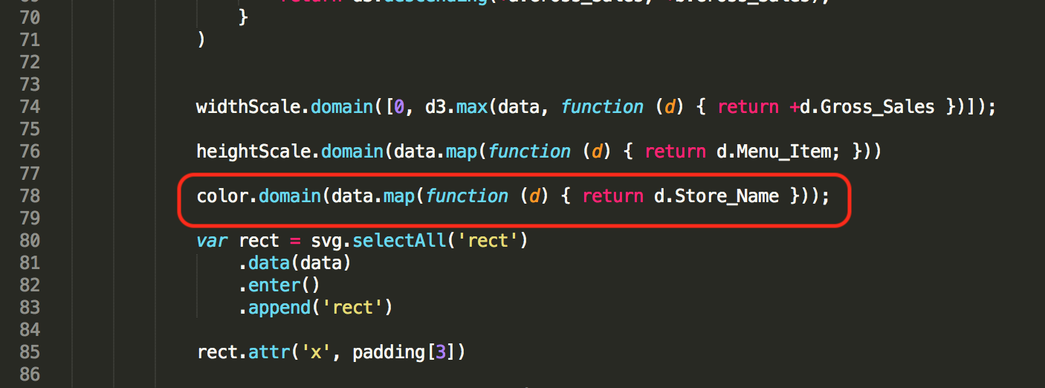

Code Explanation:

* + The domain value for the scale can be set using the Store Name present in the dataset.
* Finally to fill each bar/rectangle with color add below piece of code:

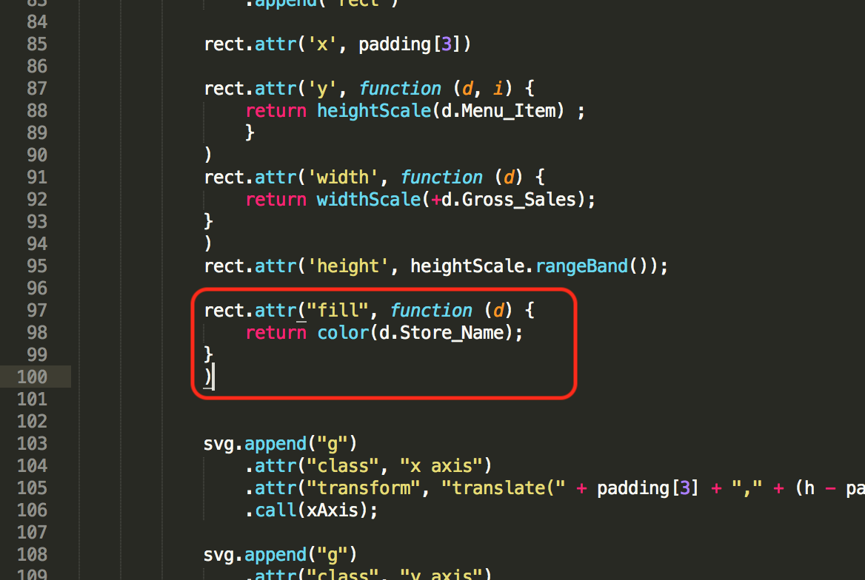

Code Explanation:

* + The color in the rectangle can now be filled using the categorical "color" scale created in previous steps.
  + Thus, the input values of store for each rectangle will decide the color for the rectangle using the output range of the scale "color" that is set in the previous steps.

**Question:**

1. **Provide the screenshot of your html page displaying your name in the browser tab:**

Answer

---------------------------------------------------------------------------------------------------

Step 14: Add title to your graph

* To add graph title at the top we first need to increase the top padding, change top padding from 20 to 30

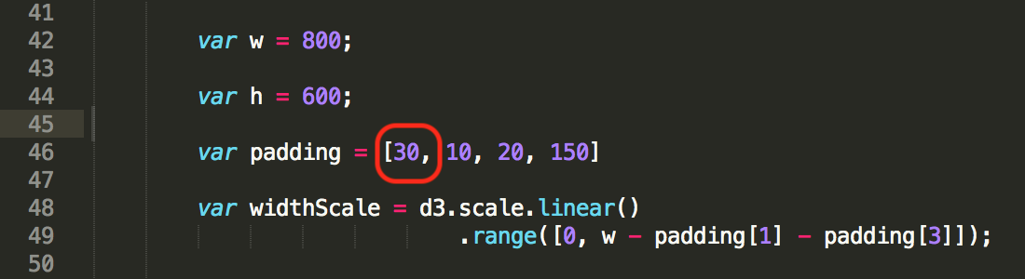

Note: If any of the labels or x axis is cut off, change values in padding accordingly.

Any Visualization shouldn’t have cut off labels.

* To display title add text to svg image

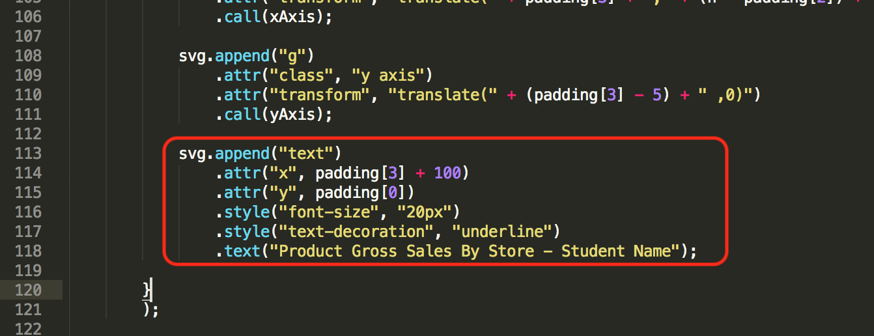

Code Explanation:

* + Title for the svg frame can be appended using the append function and setting the values of the text attribute to the desired values.

**Question:**

1. **Provide the screenshot of your html page displaying your name in the browser tab:**

Answer

---------------------------------------------------------------------------------------------------------------------

Step 15: Add legend

* To add legend in the graph we need to add following piece of code:
* Append legend group in svg image

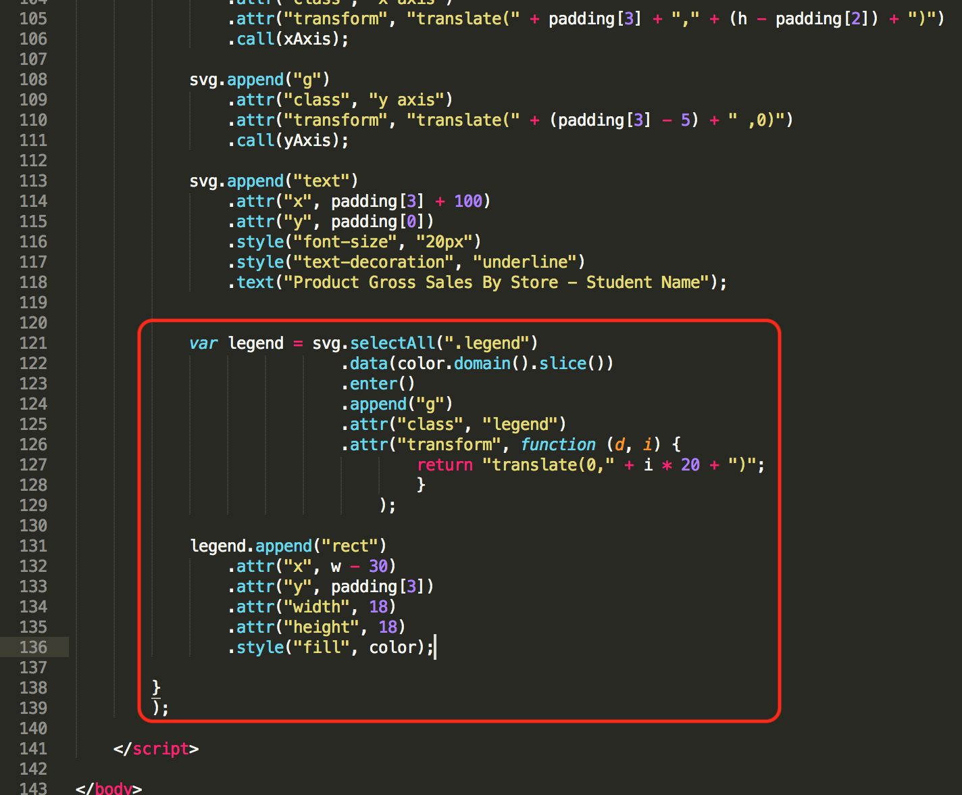

* Refresh your webpage, it should look something like this:

Add text to legend colors

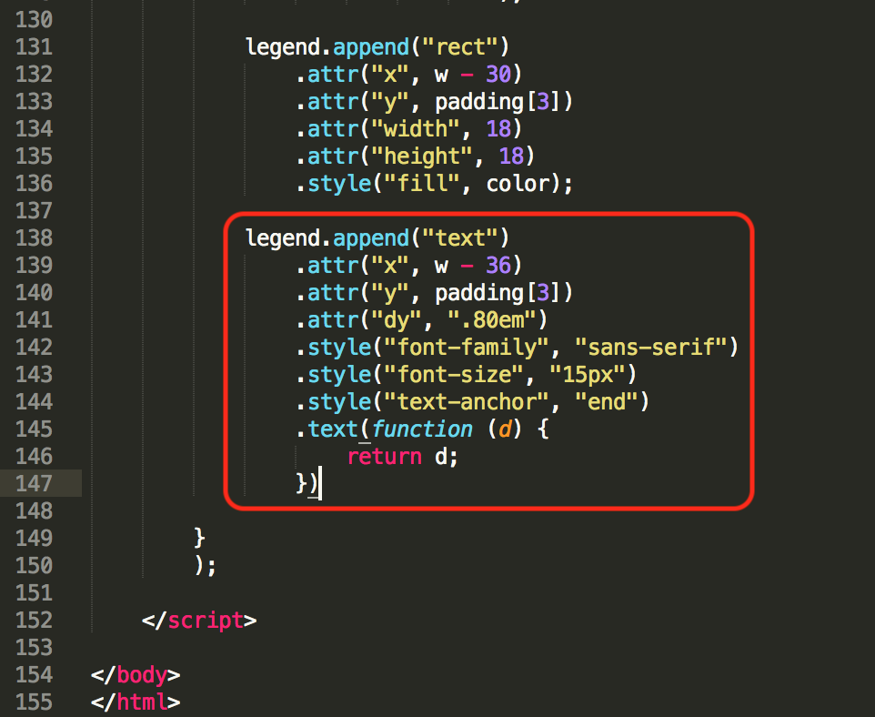

**Question:**

1. **Provide the screenshot of your html page displaying your name in the browser tab:**

Answer

Step 16: Creating a tool tip

• Open up the HTML file and append it with the pieces of code provided.

• Define a variable ‘div’ just like how we defined the axes and scales.

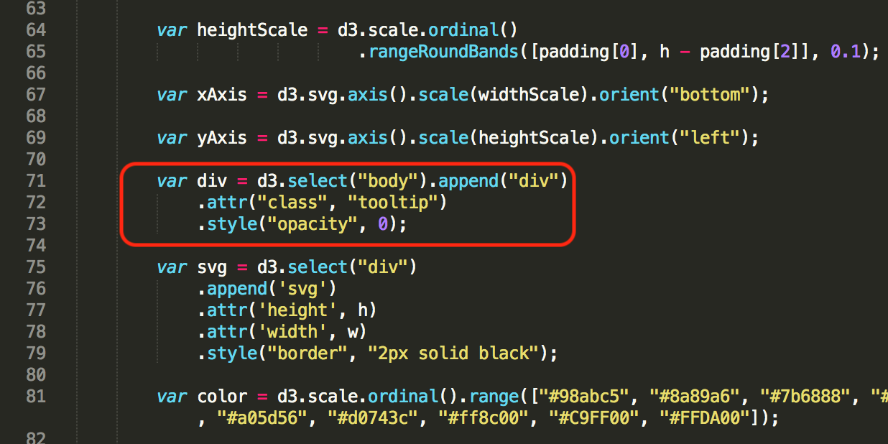

• After defining the variable, we have to make sure that when we hover over certain rectangles defined in the bar graph. To ensure this, D3 had pre defined functions ‘mouseover’ and ‘mouseout’.

• We will make use of these functions as transitions available for 200 seconds.

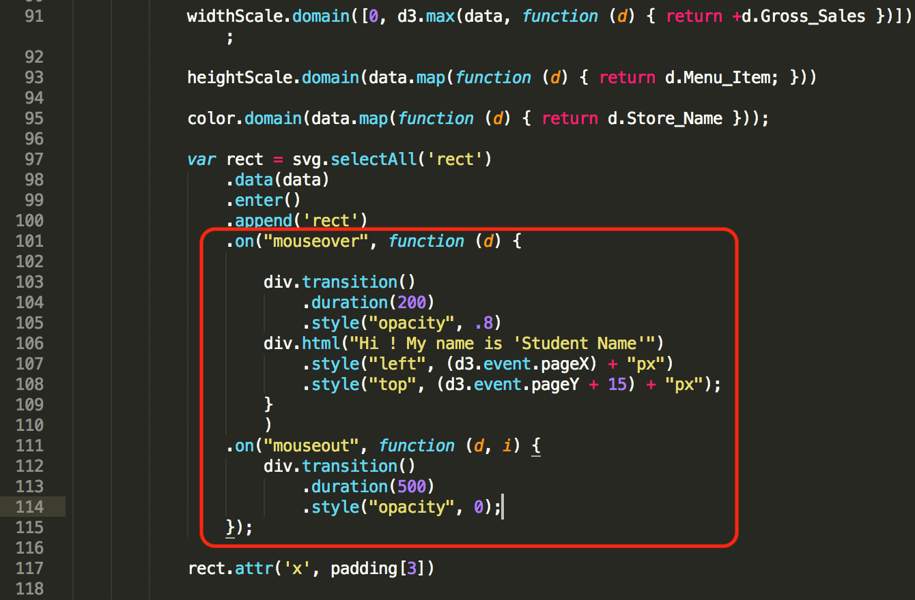

• Now to adjust the properties of the tooltip, we will define a class ‘tooltip’ in the CSS section

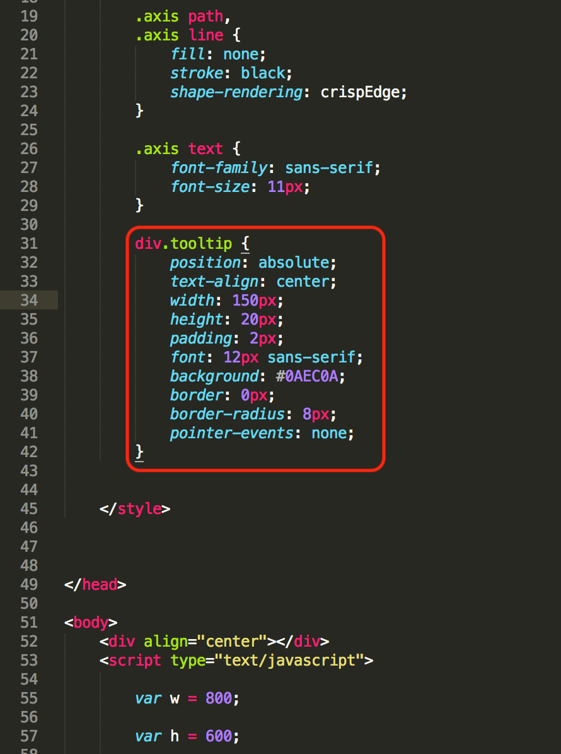

• Properties of the Tooltip can be adjusted, feel free to modify them in any manner you feel is the most suitable considering the color scheme of the graph. At the least, PLEASE CHANGE THE COLOR FROM NEON GREEN AS DEFINED IN THE PROPERTIES HERE. YOU WILL BE DISCOUNTED IF YOU FAIL TO DO SO.

**Question:**

1. **Paste a screenshot of the whole output screen with timestamp.**

Answer:

Step 17 : Highlighting

• Highlighting is a very crucial part of any visualization. We are going to highlight the rectangles.

• This is also to be done in the ‘mouseover’ and ‘mouseout’ functions of the variable ‘rect’

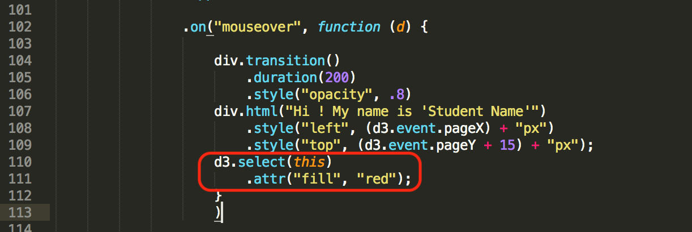

Now, ‘mouseout’ contains a return function to return the color of the rectangle to what it was initially.

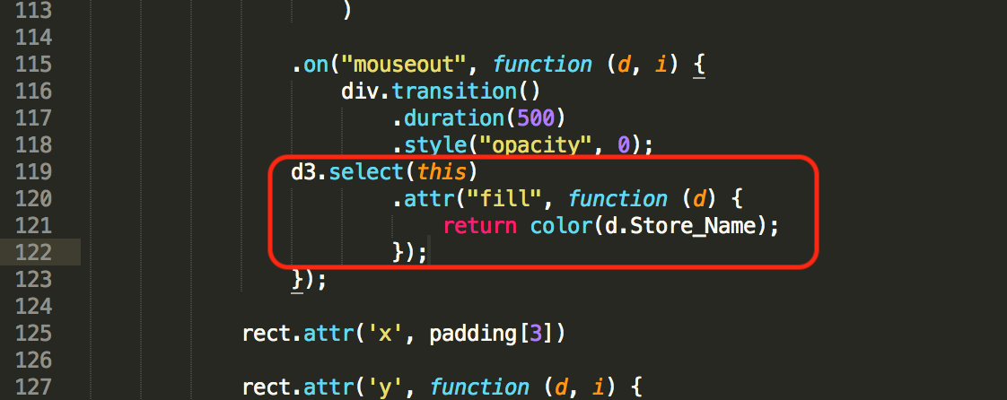

**Question:**

**13. Paste of screenshot hovering over a bar of the graph displaying the highlighting and the tooltip**.

Answer:

Step 18: Making changes to the tooltip text

• Returning variables in tooltip is very important. Now we will modify the text displayed in the tooltip.

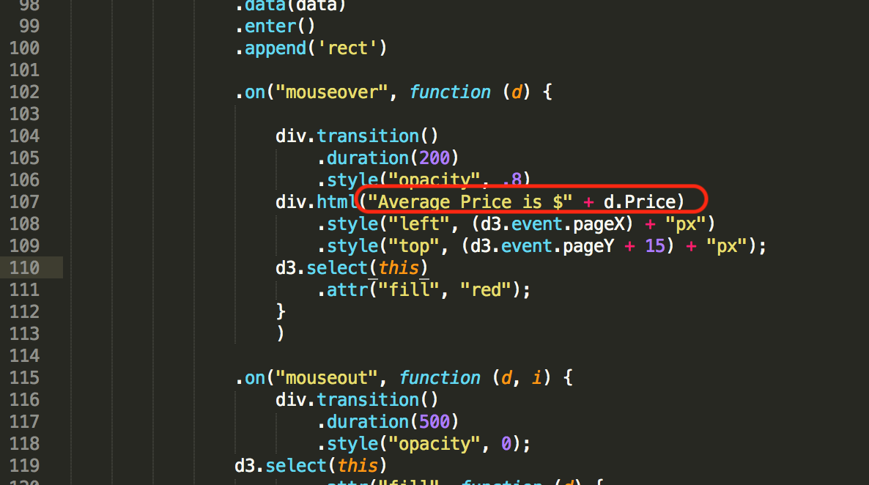

**Question:**

**14. Paste a screenshot of the tooltip showing the average price**.

Answer:

---------------------------------------------------------------------------------------------------------------------

**Instructions for submission**

1. **Submit two files to eLearning in a compressed zip file. eLearning will not accept some of the file types if they are not zipped.**
   1. **Submit your HTML file.**
   2. **Submit your word answer document. (without the steps)**